 

**FACULTY OF COMPUTERS AND ARTIFICIAL INTELLIGENCE, CAIRO UNIVERSITY**

**Data Warehouse(Spring 2025)**

**CoffeeShop DataWarehouse Project**

**Team Members:**

|  |  |
| --- | --- |
| **Name** | **ID** |
| Menna Hassan Helmy | 20220345 |
| Nada Ibrahim Mohamed | 20220358 |
| Ahmed Hegazy Ahmed | 20220015 |

1. 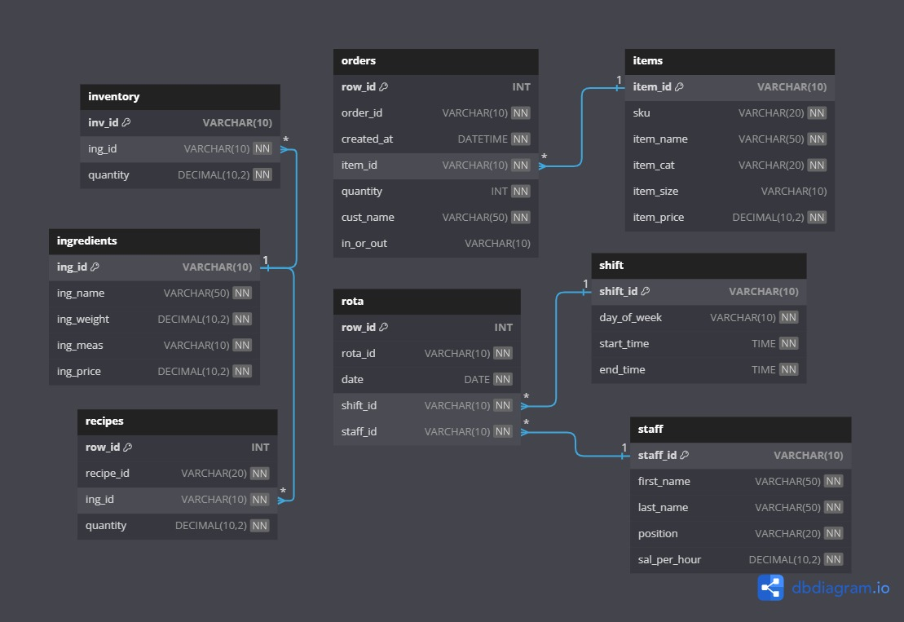Physical model of the source system
2. The business processes that we will model.

• **Sales Tracking** – capturing item sales per customer and order.

• **Staff Cost Management** – recording staff working hours and related costs.

• **Recipe Cost Analysis** – analyzing the cost and profitability of recipes used in menu items.

• **Customer Visit Analysis** – tracking monthly visits and spending by customers

1. **Fact Tables:**

1. Fact_Sales

* **Type**: Transaction fact table
* **Measures**:
  + item_quantity (additive)
  + sales_amount (additive)
* **Grain**: One record per item sold in an order on a specific date for a specific customer and order type (captures the quantity and dollar amount for each item sold together)
* **Dimensions**:
  + Date (date_id)
  + Customer (cust_id)
  + Order Type (order_type_id)

2. Fact_Staff_Cost

* **Type**: Periodic Snapshot fact table
* **Measures**:
  + worked_hours (additive)
  + sal_per_hour (non-additive)
  + cost (additive)
* **Granularity**: One record per staff per shift per date, capturing salary and hours worked (records each work session’s hours and resulting labor cost for every staff–shift occurrence)
* **Dimensions**:
  + Staff (staff_id)
  + Shift (shift_id)
  + Date (date_id)

3. Fact_Recipe

* **Type**: Transactional fact table
* **Measures**:
  + item_price (additive)
  + total_cost (additive)
  + profit (additive)
* **Granularity**: One record per item-recipe combination, capturing cost and profit. (logs the cost and profit contribution of each ingredient used in a given recipe.)
* **Dimensions**:
  + Recipe (recipe_id)
  + Item (item_id)

4. Fact_Customer_Visits_Monthly

* **Type**: Periodic snapshot fact table
* **Measures**:
  + visit_count (semi-additive)
  + total_spent (semi-additive)
* **Granularity**: One record per customer per month per year, summarizing visits and total spending. (One record per item-recipe combination, capturing cost and profit.)
* **Dimensions**:
  + Customer (customer_id)

1. **Dimension Tables**
2. Recipe_Dim

* **Type**: Slowly Changing (type 1)

1. Ingredients_Dim

* **Type**: Static

1. Item_Dim

* **Type**: Slowly Changing (type 1), Conformed

1. Staff_Dim

* **Type**: Slowly Changing (type 2)

1. Shift_Dim

* **Type**: Static

1. Dim_Date

* **Type**: Conformed, Role Playing dimension

1. Dim_Customer

* **Type**: Conformed, Slowly Changing (type 2)

1. Physical Model of The Schema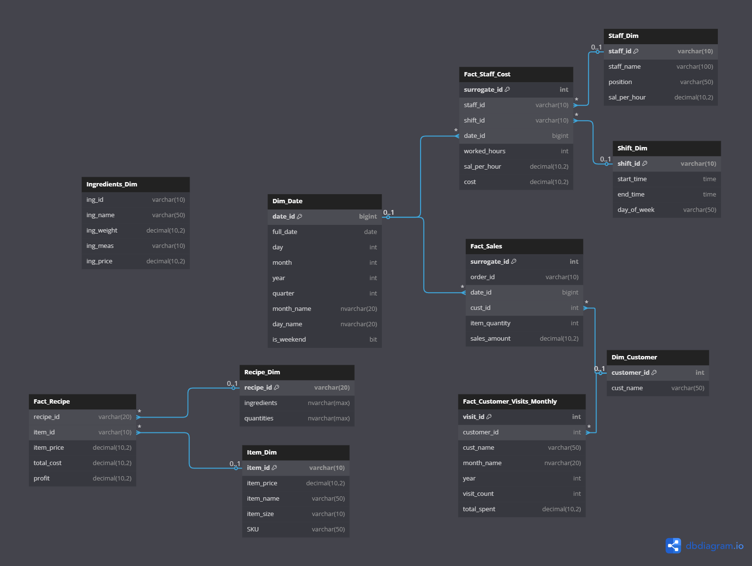

SCHEMA

1. SSIS Control and Data Flow

* 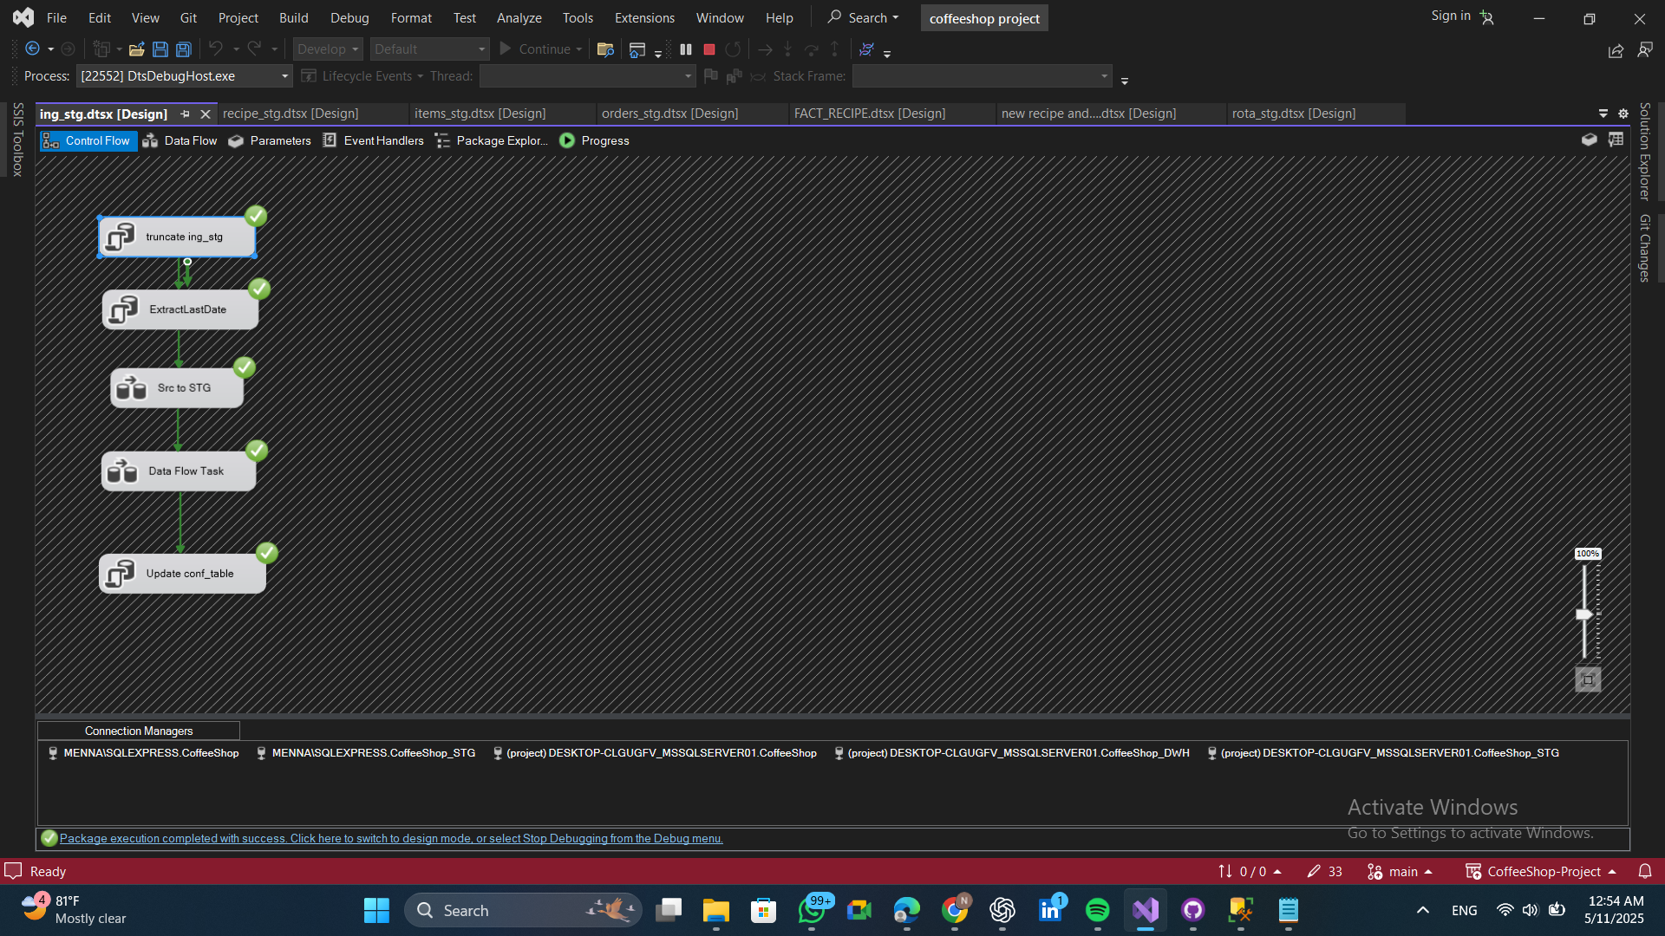**Ingredients** control flow 🡪 Delete all data from the staging table to prepare for new inserts or updates, and update the last extract date in the configuration table.
* **Ingredients** data flow
* 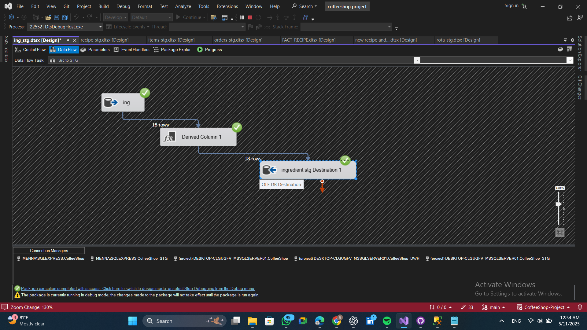Transfer data from the source database into the ingredient table in the staging area.
* 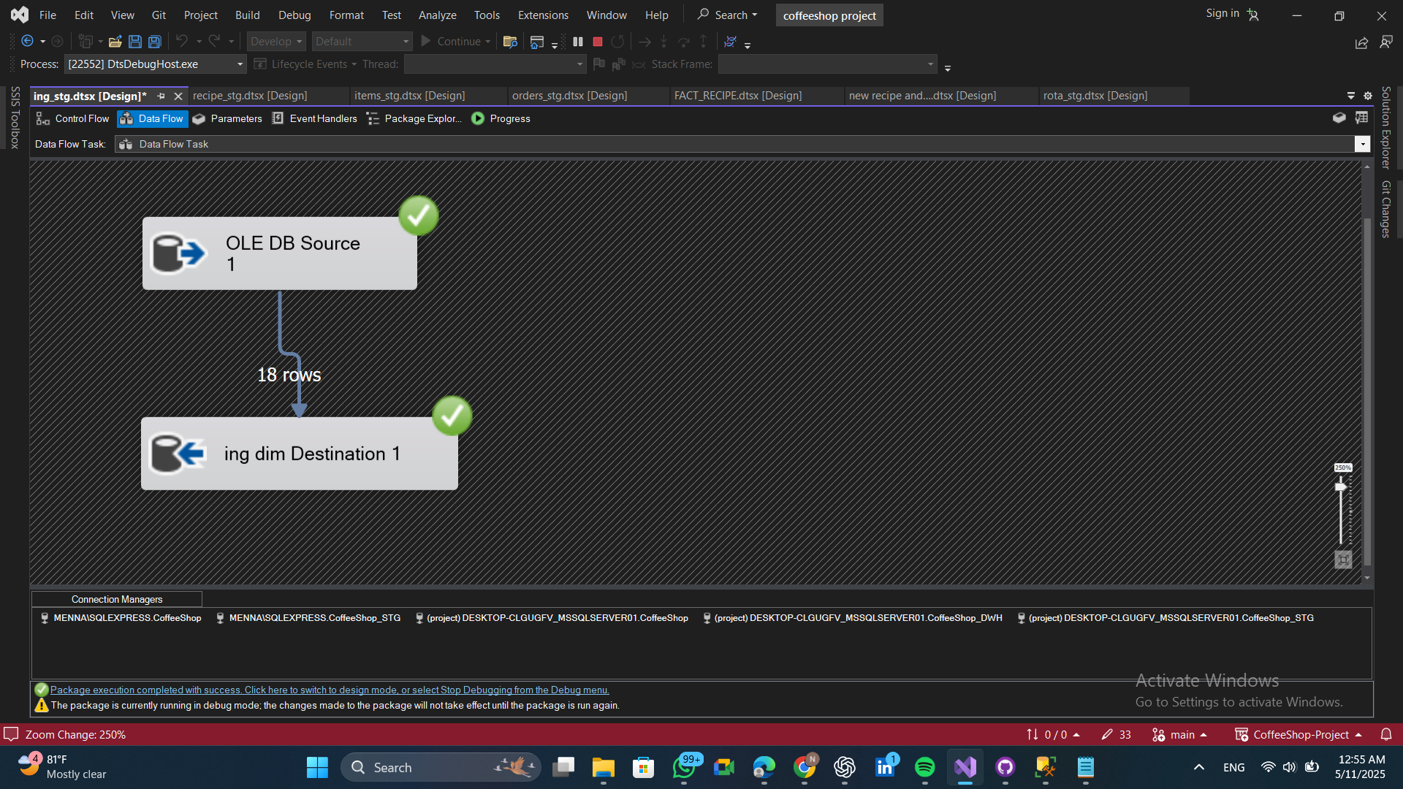Load data from the ingredients table in the staging area into the dimension table in the data warehouse
* 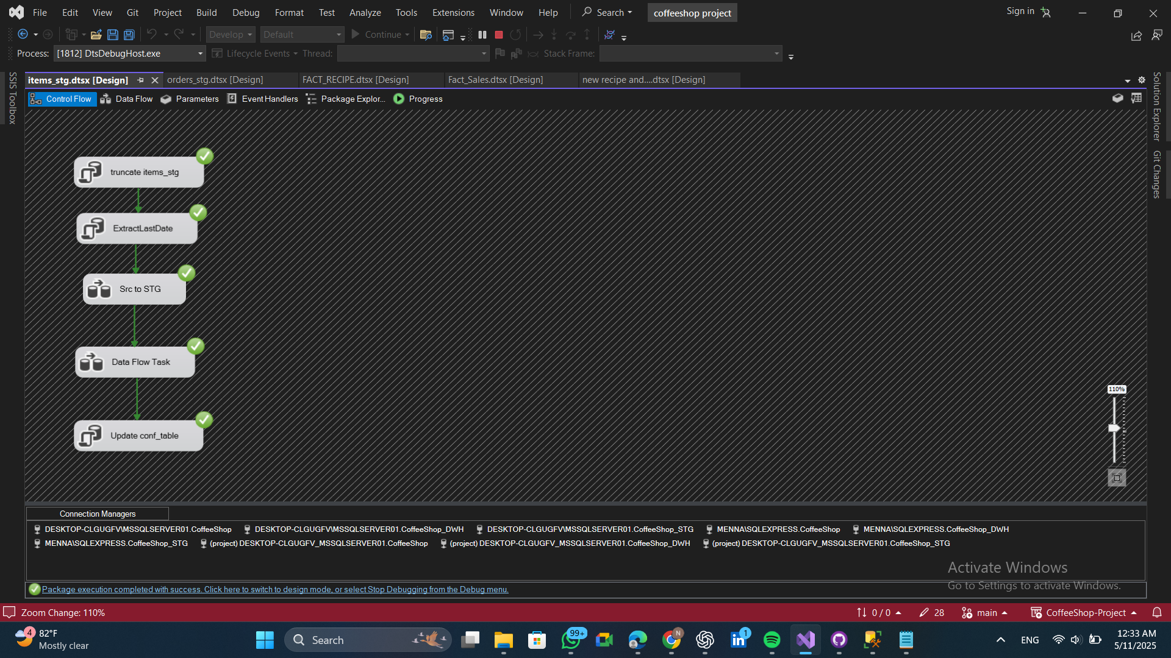**Items control flow** 🡪 Delete all data from the staging table to prepare for new inserts or updates, and update the last extract date in the configuration table.
* **Items data flow**
* 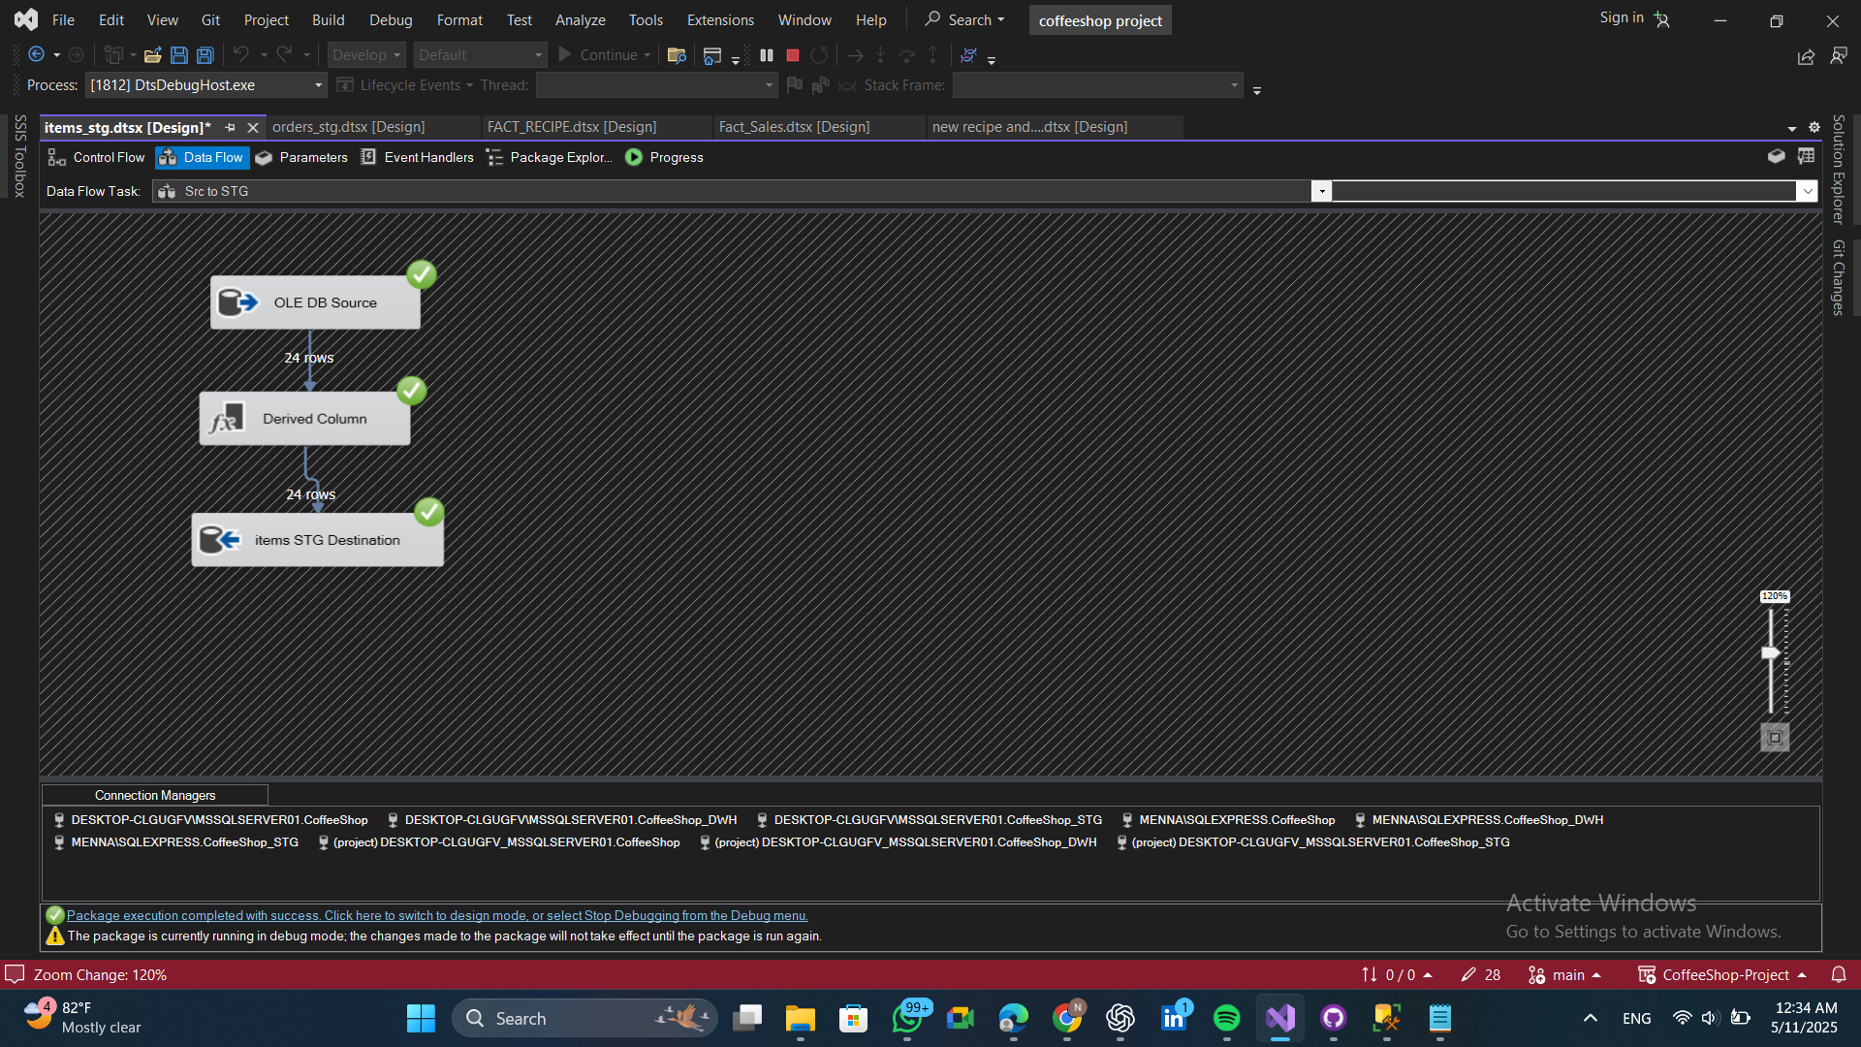Extract data from the source and load it into the staging area.
* 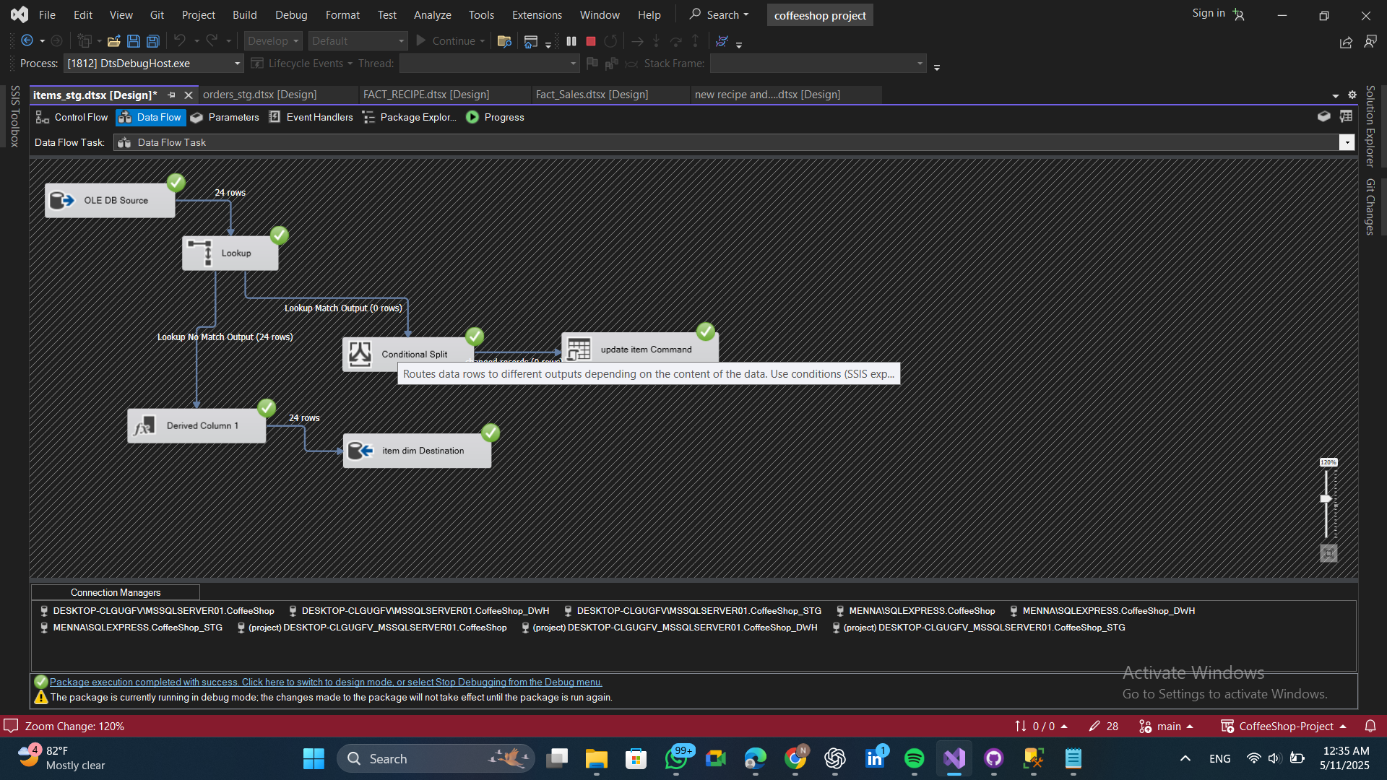 Retrieve data from the staging area, perform a lookup to determine if the data is new or updated, and then insert or update the items dimension table accordingly
* 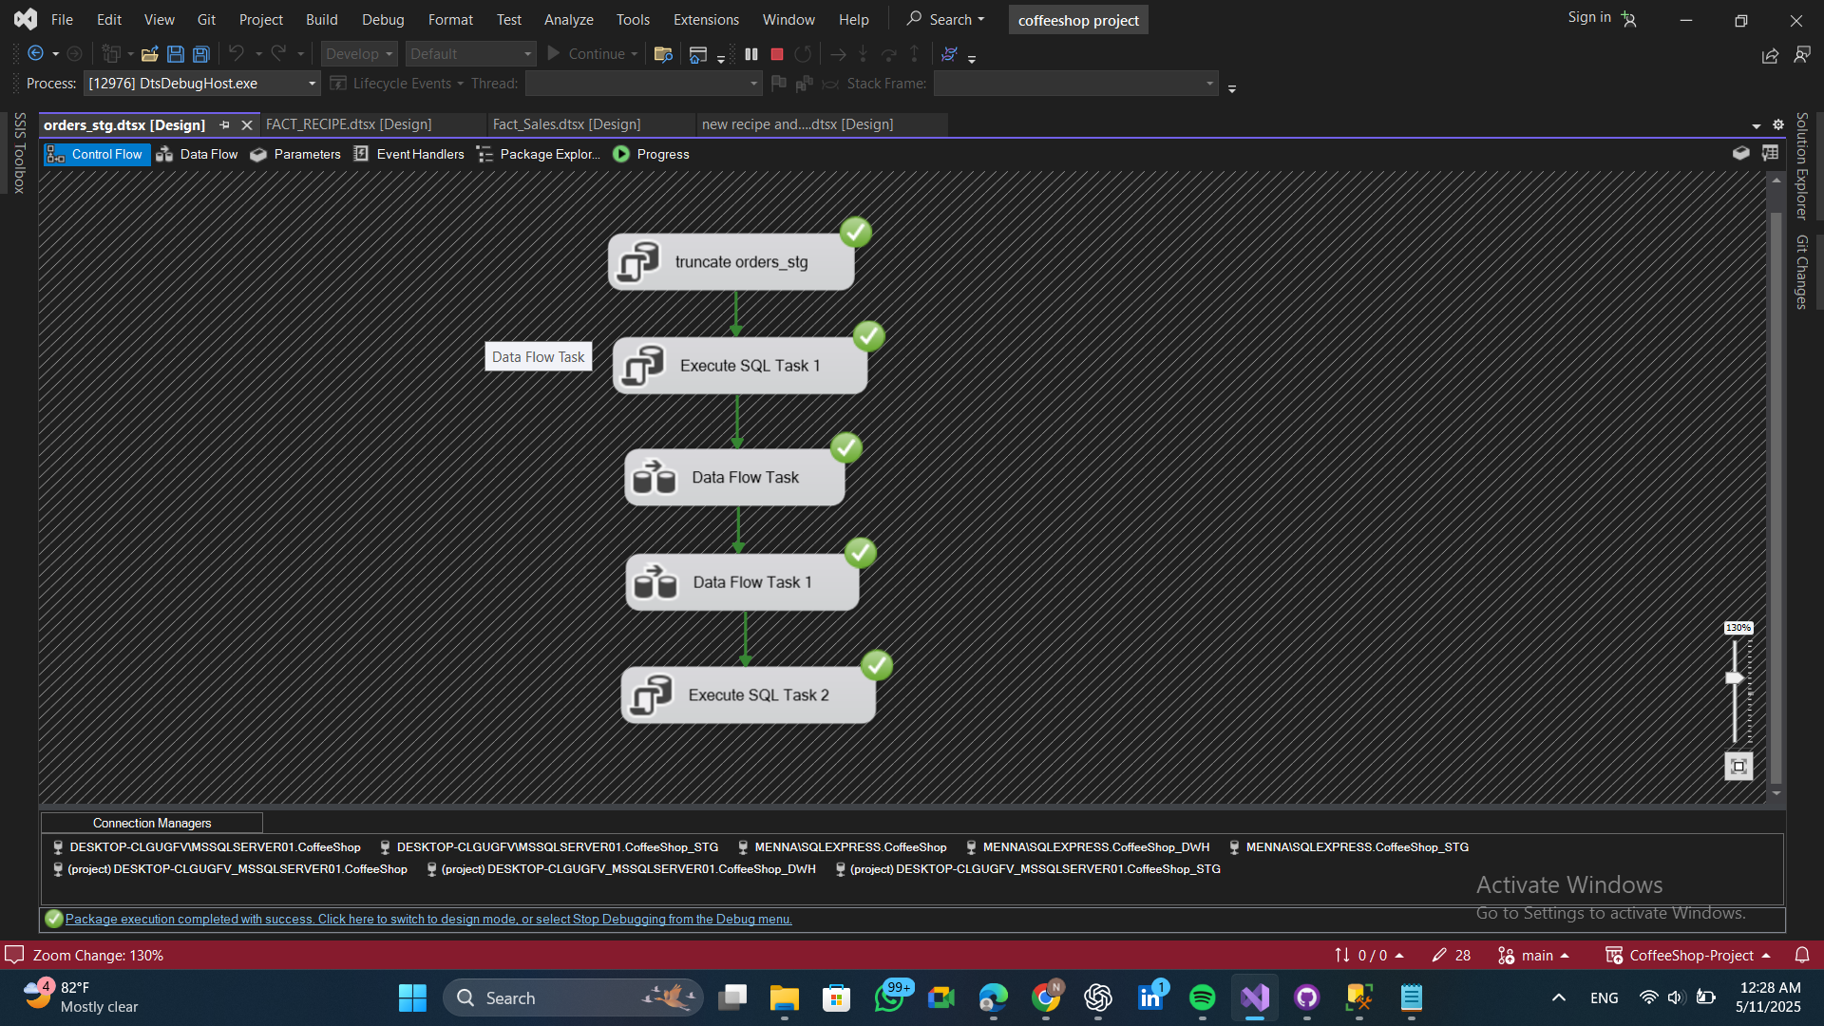**Orders control flow** 🡪 Delete all data from the staging table to prepare for new inserts or updates, and update the last extract date in the configuration table.
* **Orders data flow (no dimension for order table)**
* 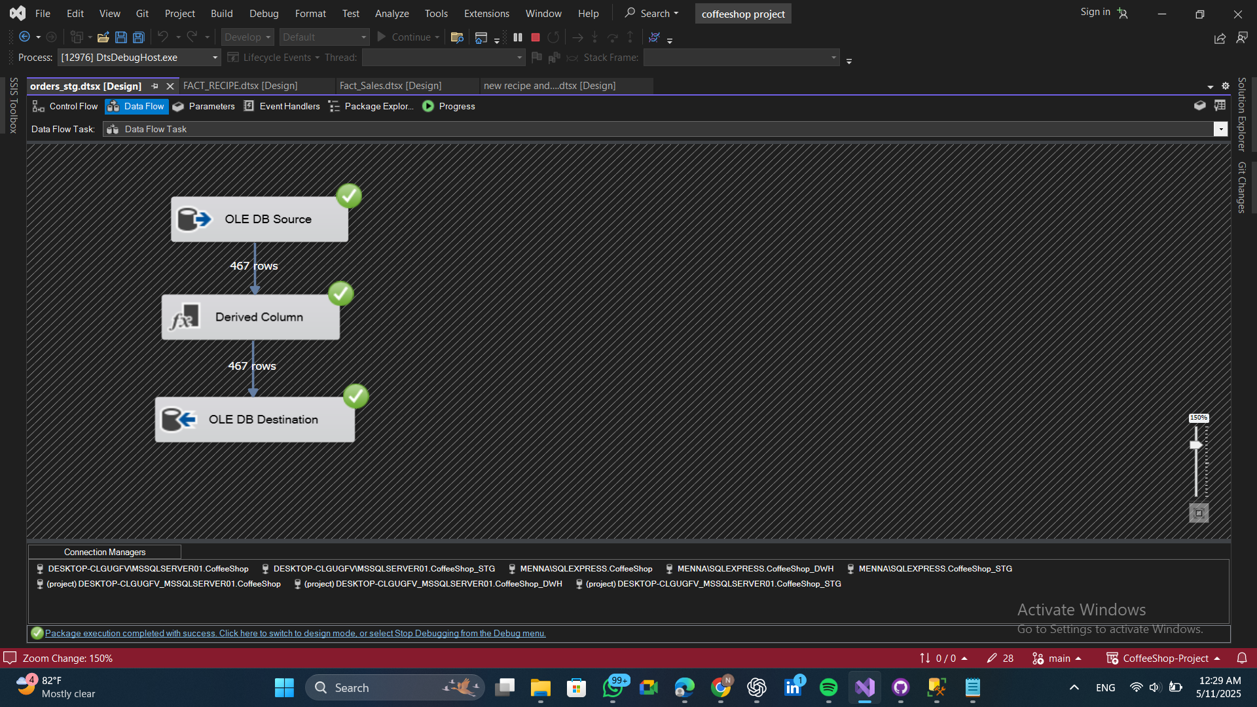Extract data from the source and load it into the staging area.
* 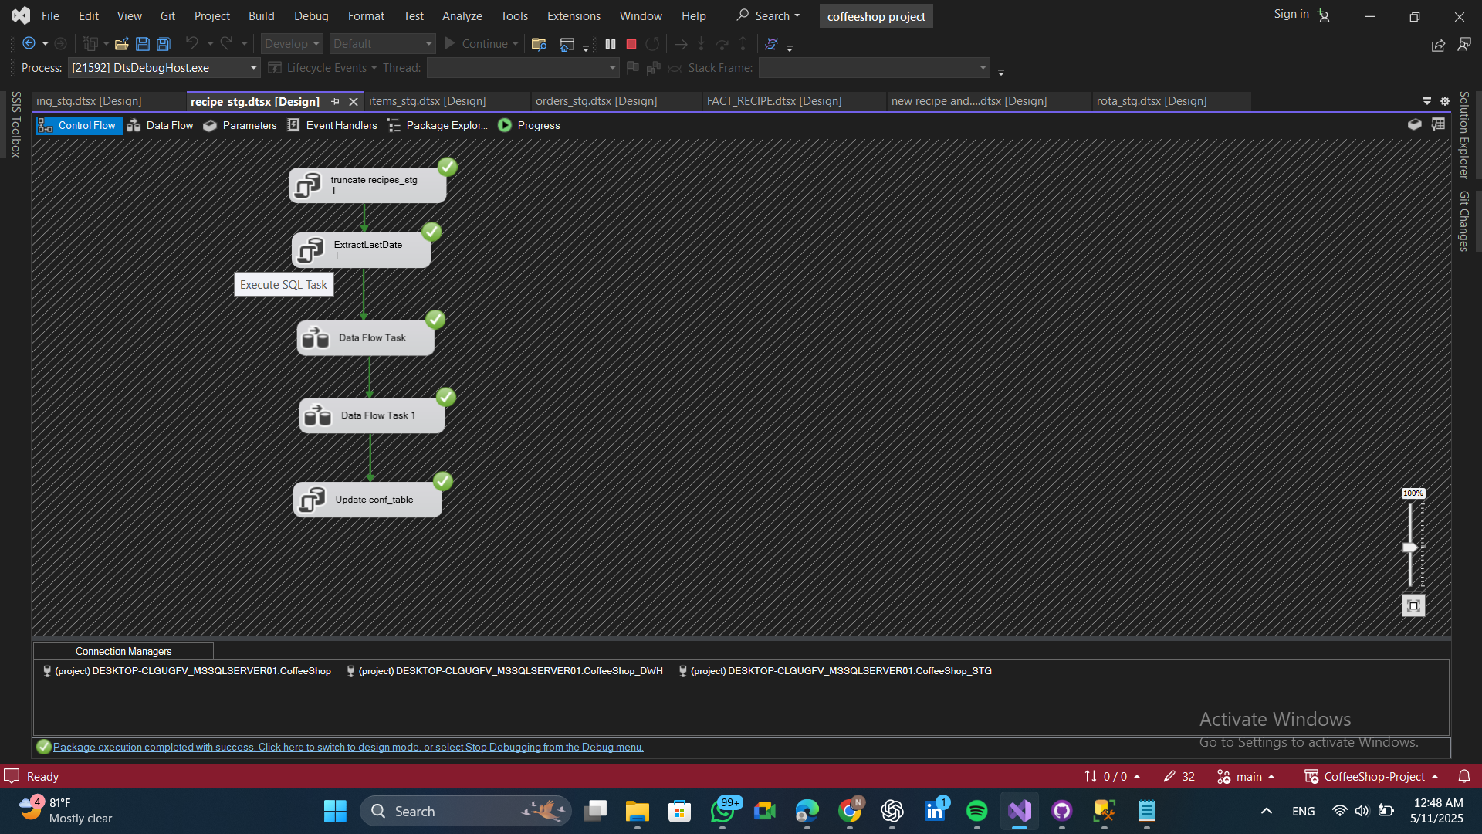**Recipe control flow** 🡪 Delete all data from the staging table to prepare for new inserts or updates, and update the last extract date in the configuration table.
* **Recipe data flow**
* 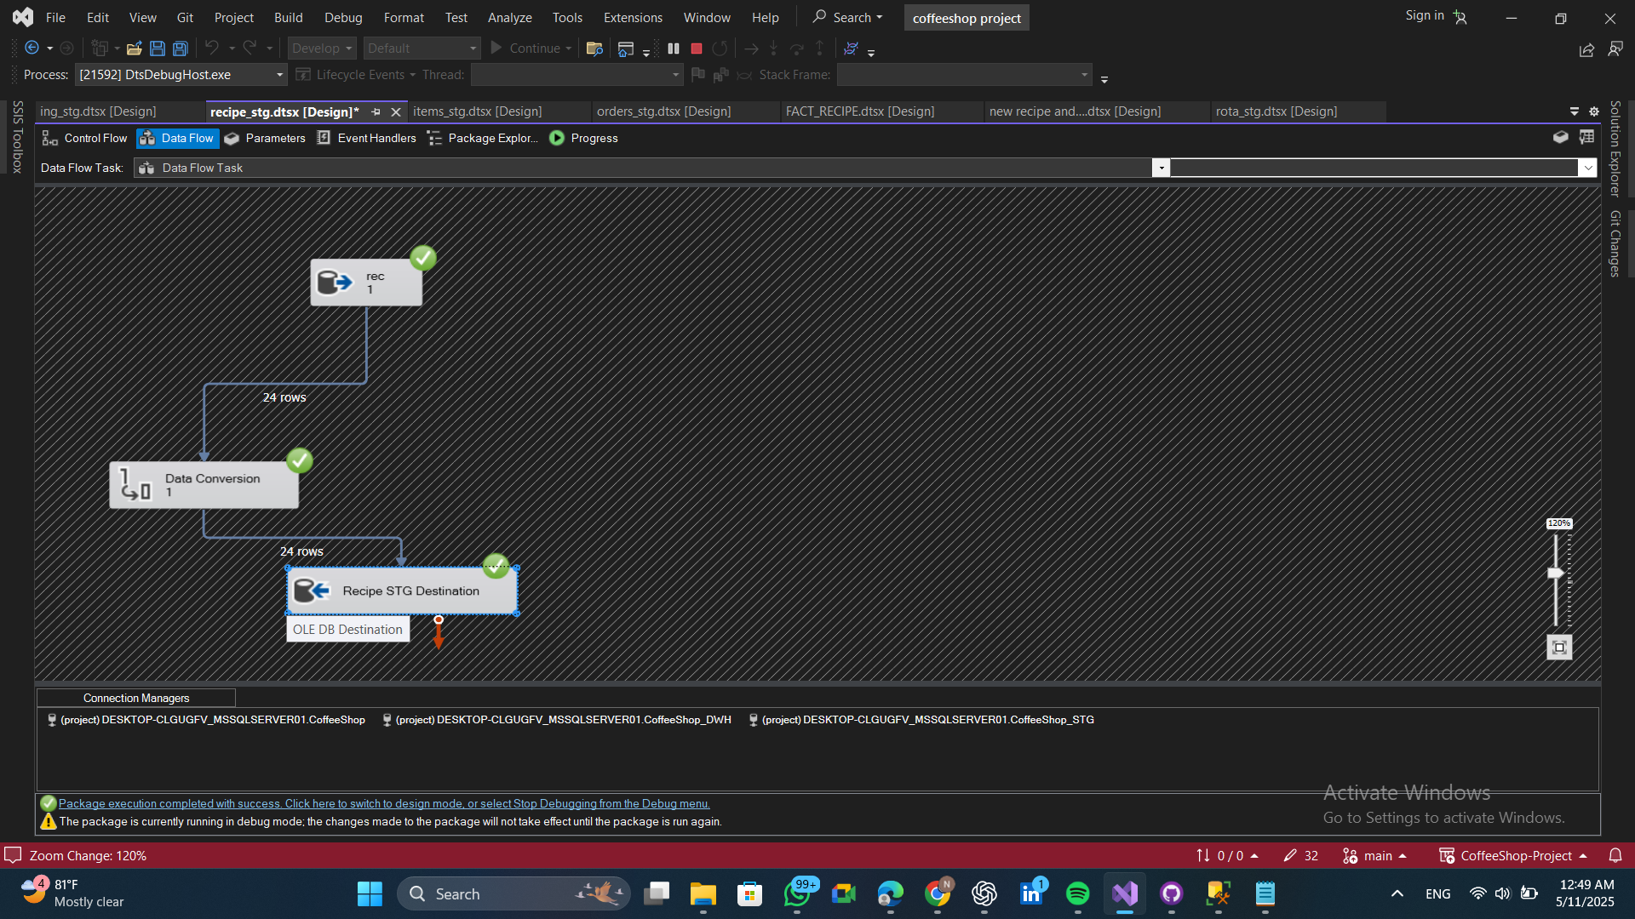Extract data from the source and load it into the staging area. (collect ingrediennds and quantities for the recipe in 1 record)
* 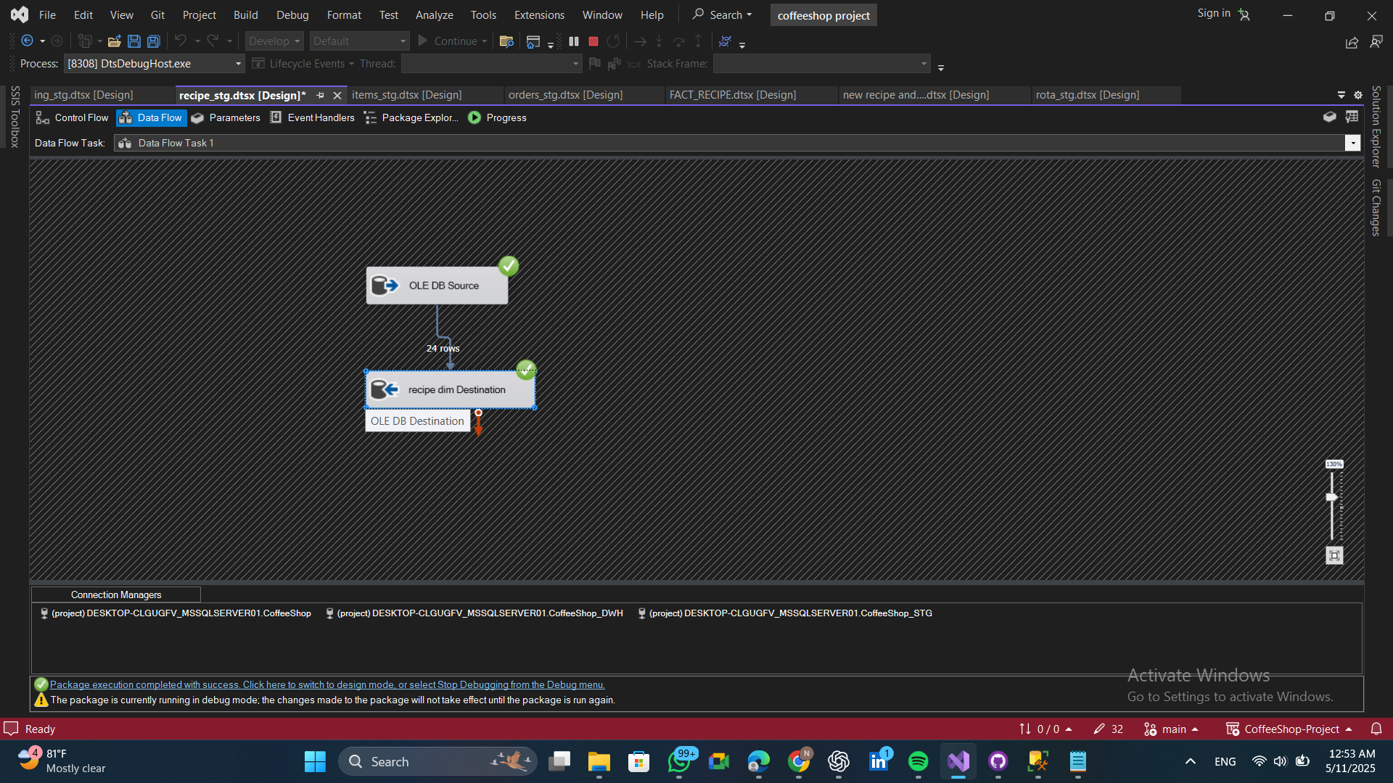 Load data from the staging area into the dimension table.
* 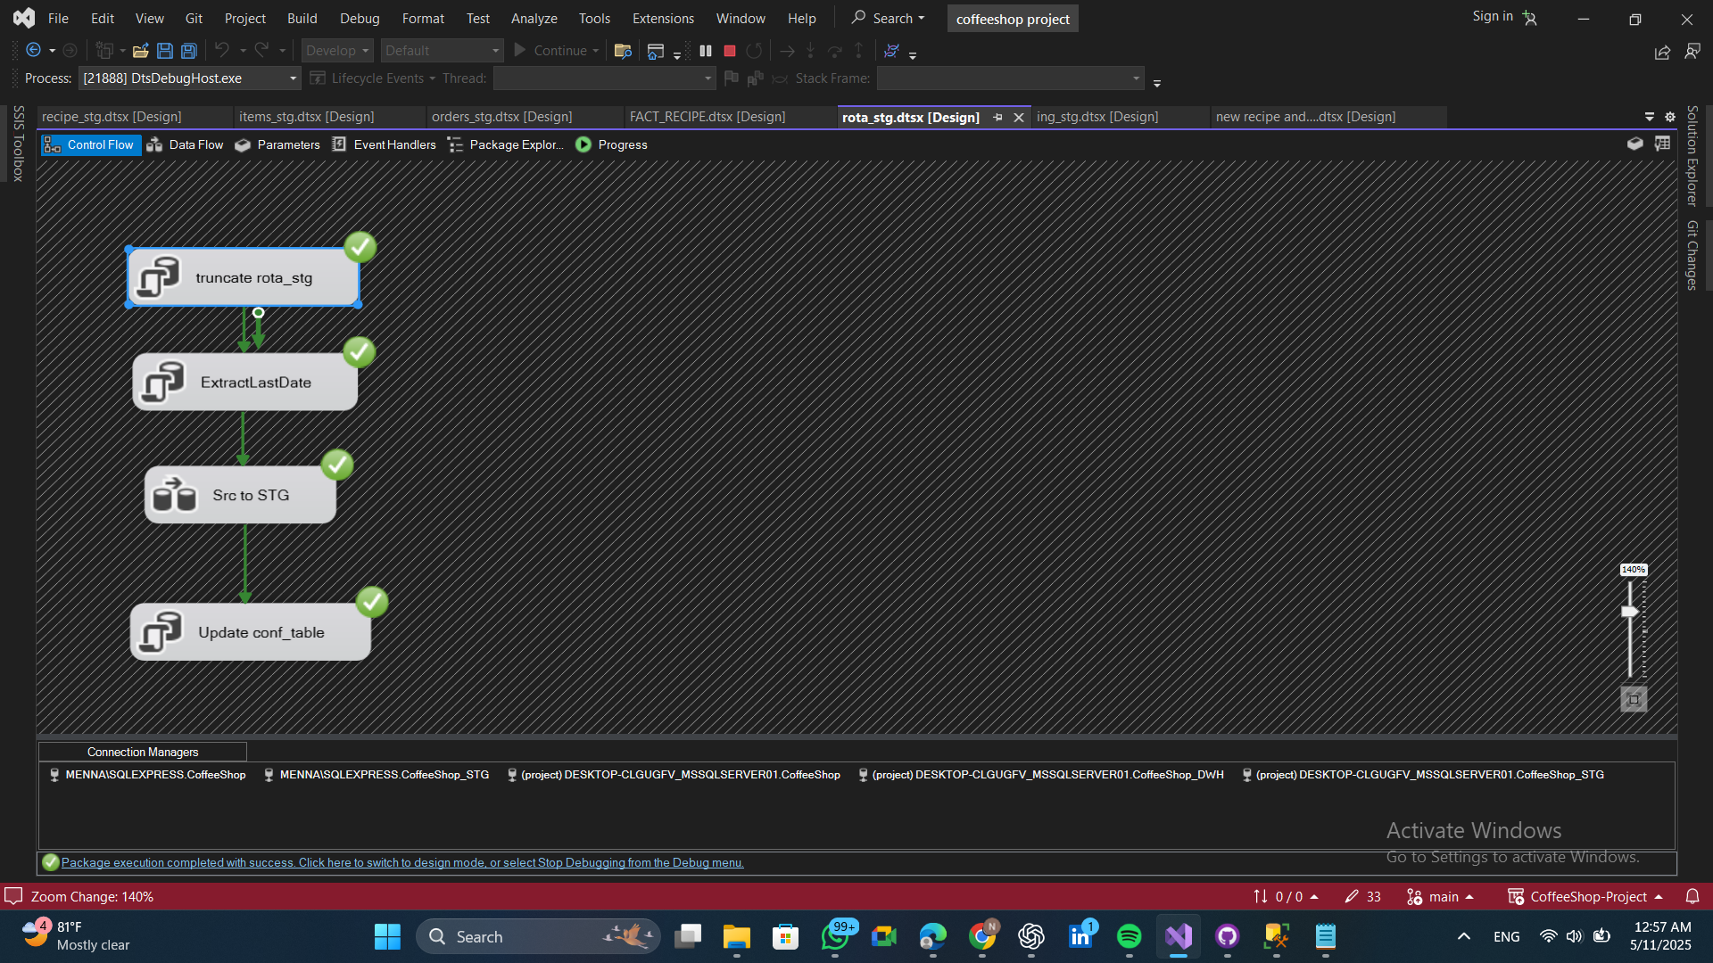**Rota control flow** 🡪 Delete all data from the staging table to prepare for new inserts or updates, and update the last extract date in the configuration table.
* **Rota data flow**
* 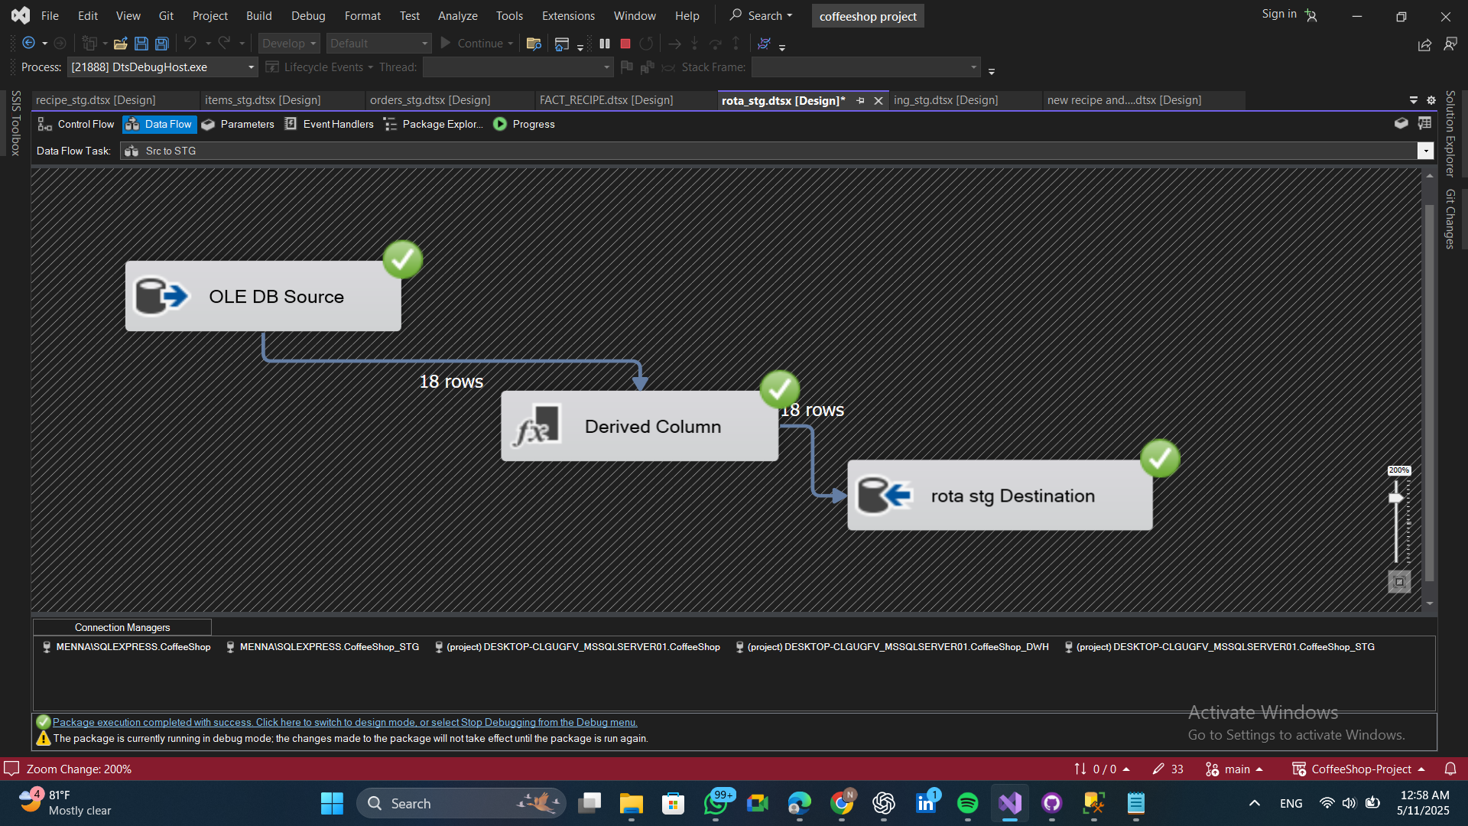Extract data from the source and load it into the staging area.
* 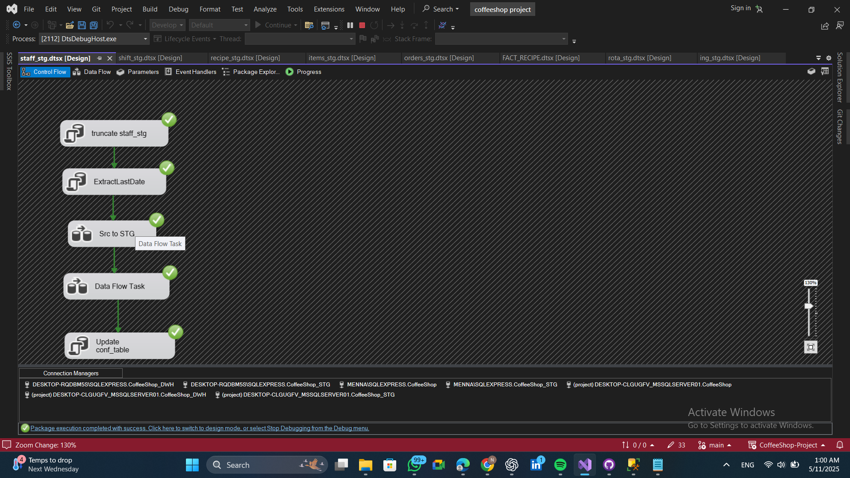**Staff control flow** 🡪 Delete all data from the staging table to prepare for new inserts or updates, and update the last extract date in the configuration table.
* **Staff data flow**
* 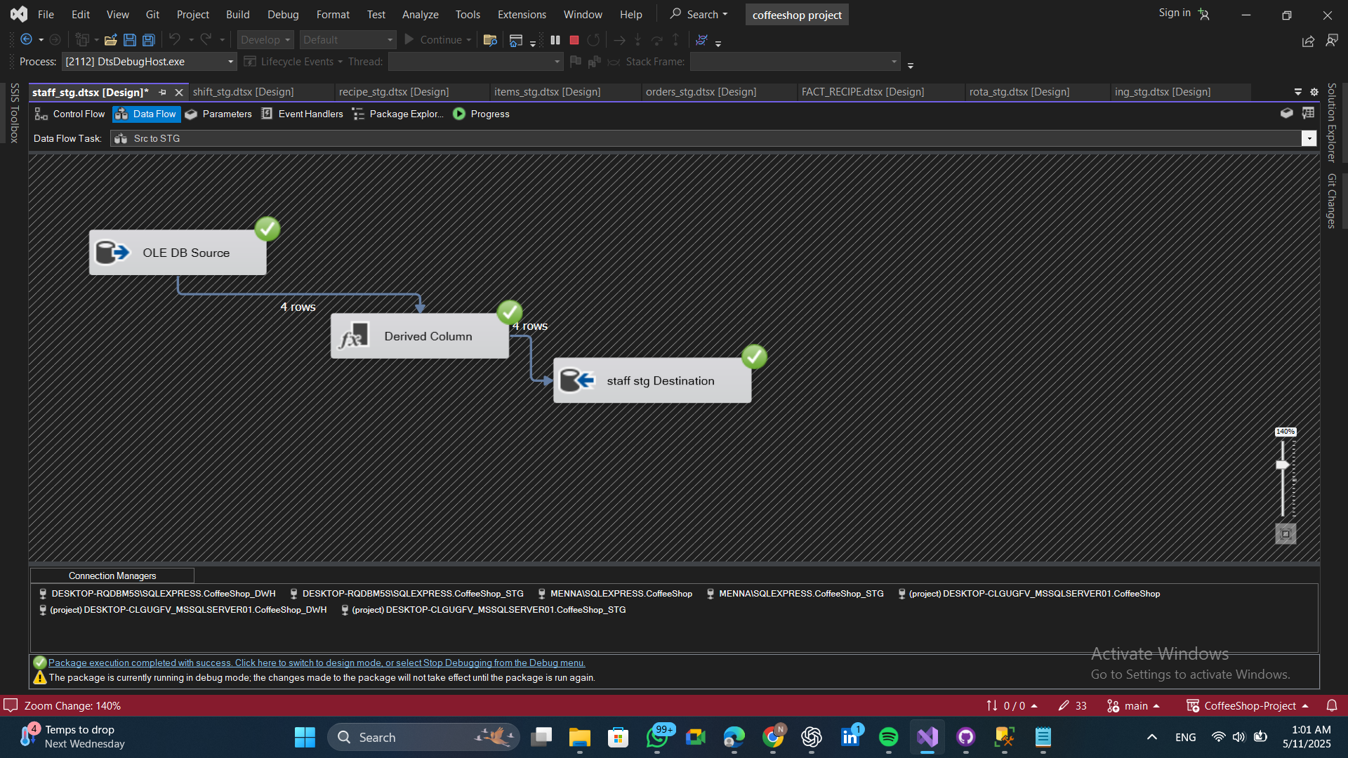Extract data from the source and load it into the staging area.
* 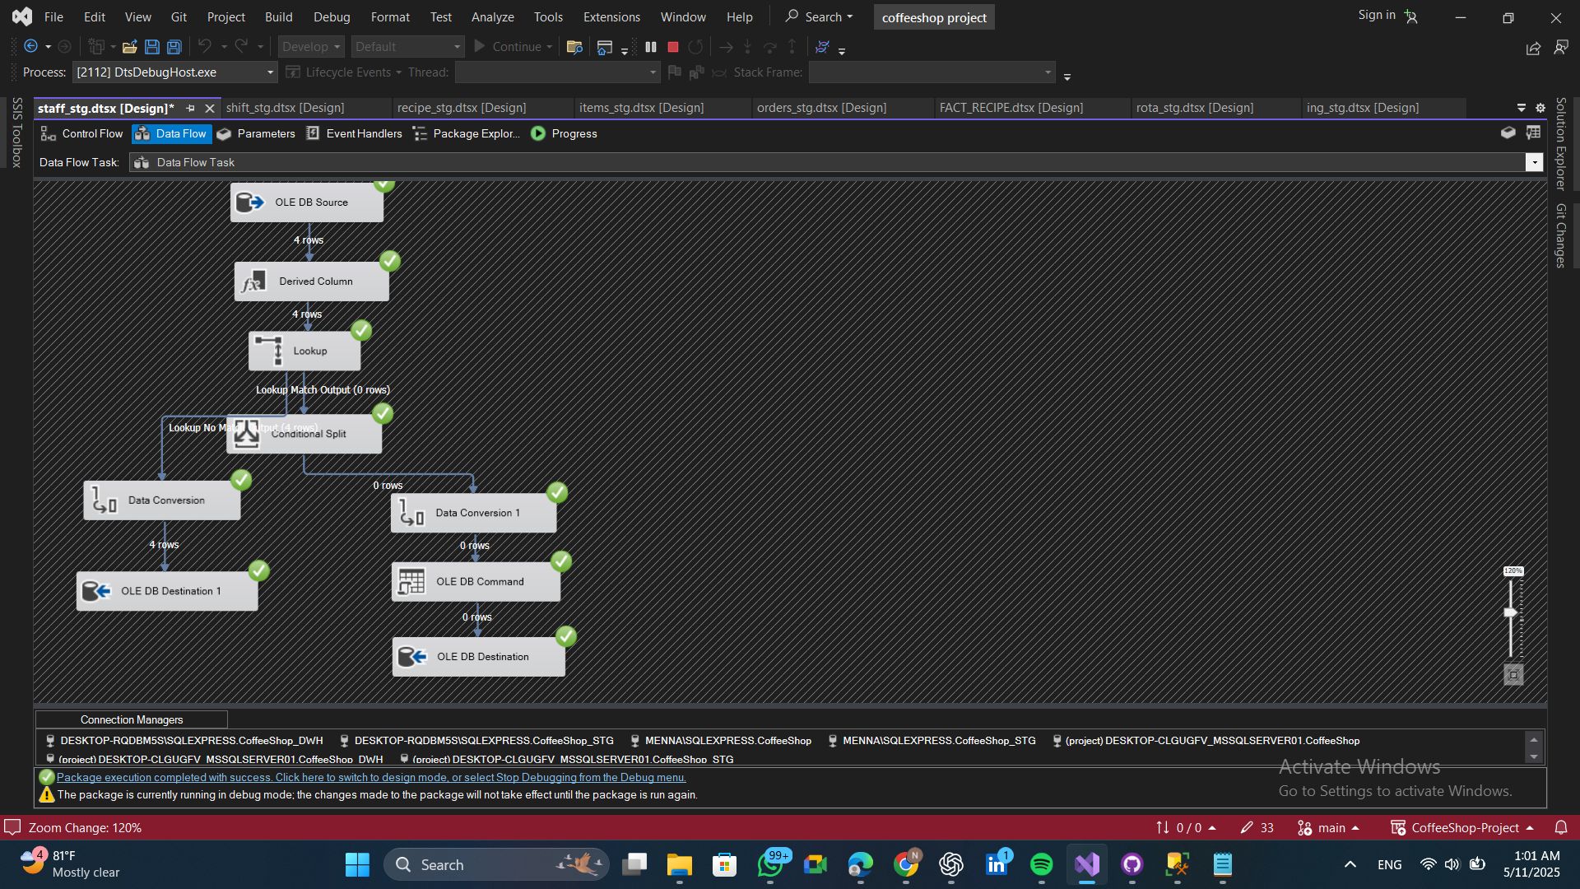 Retrieve data from the staging area, perform a lookup to compare new and old staff members, and then load the data into the dimension table
* 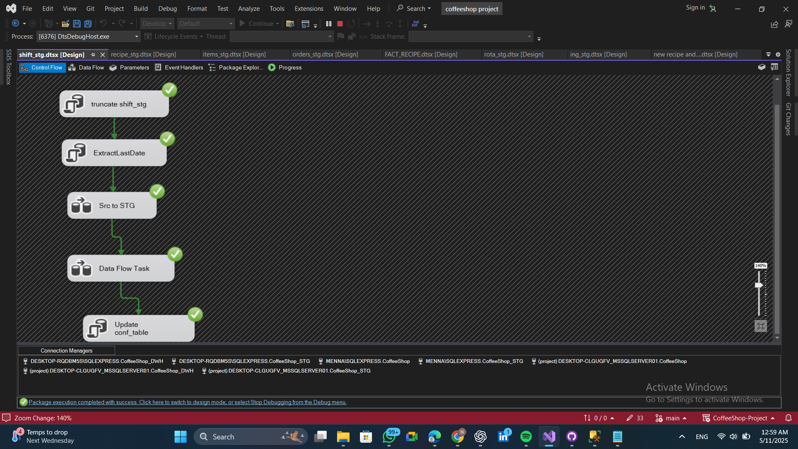**Shift control flow** 🡪 Delete all data from the staging table to prepare for new inserts or updates, and update the last extract date in the configuration table.
* **Shift data flow**
* 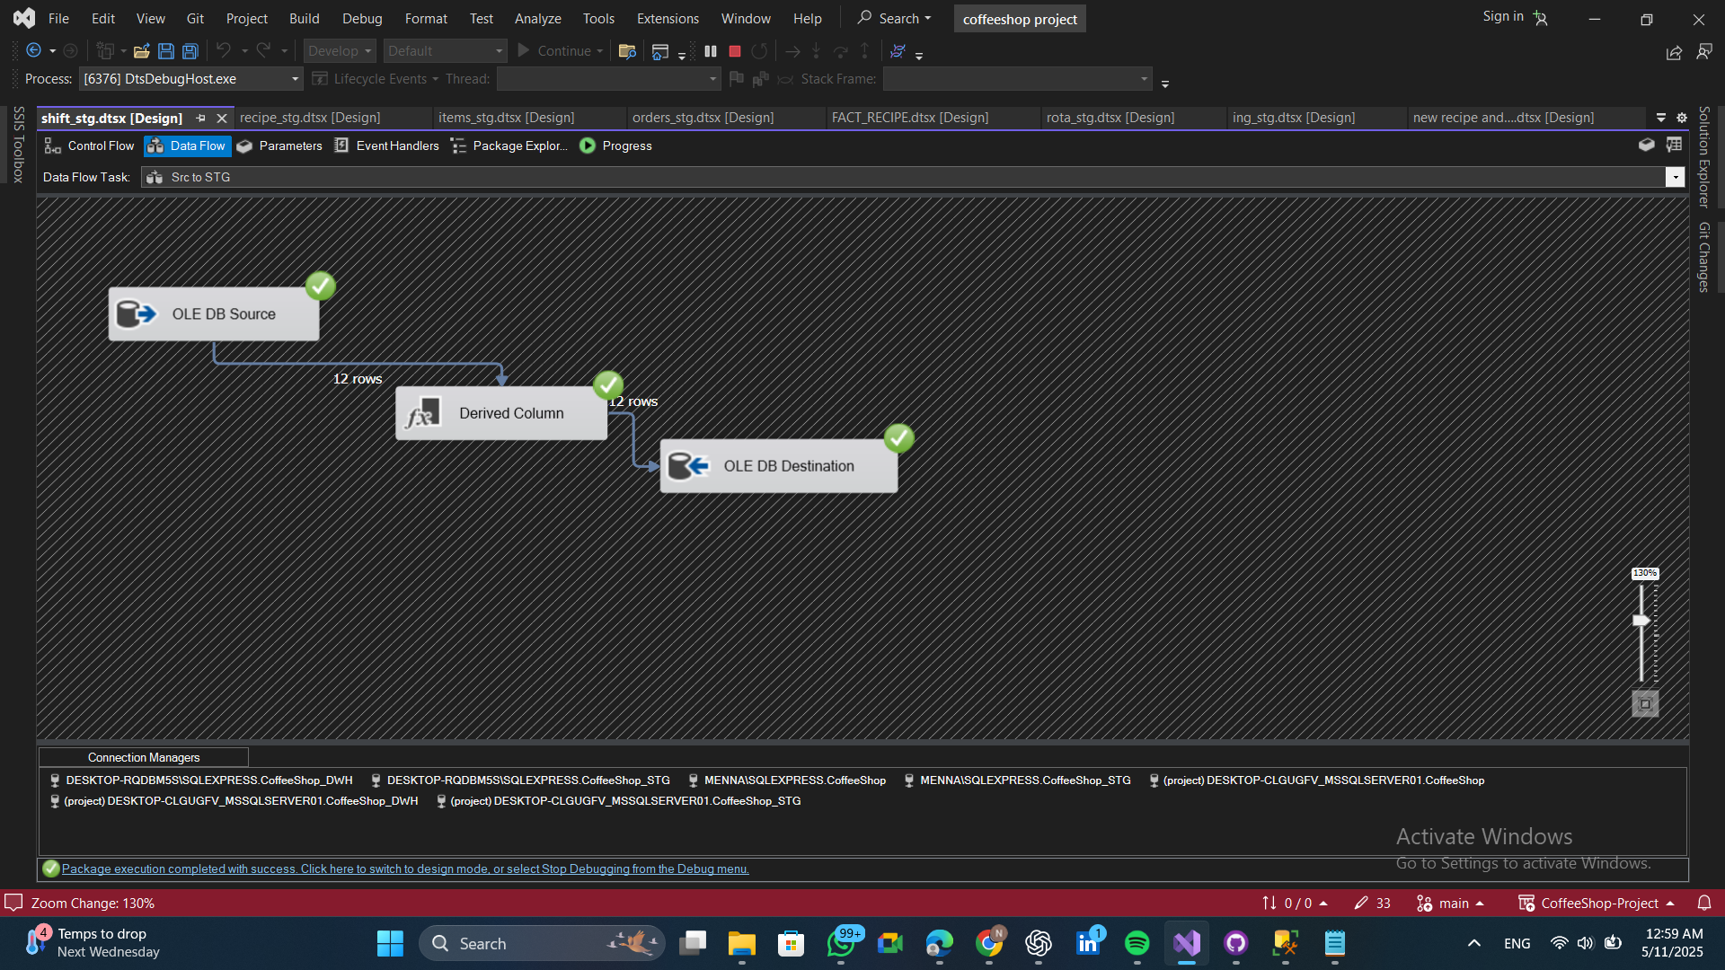Extract data from the source and load it into the staging area.
* 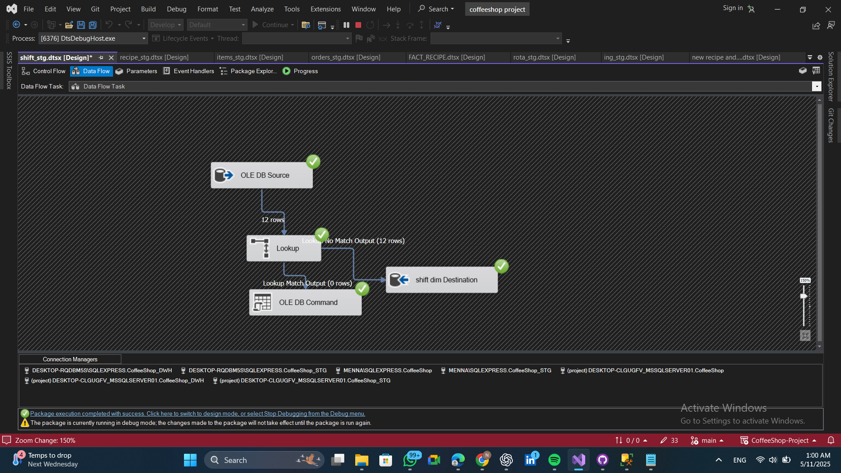 Load data from the staging area into the dimension table.
* 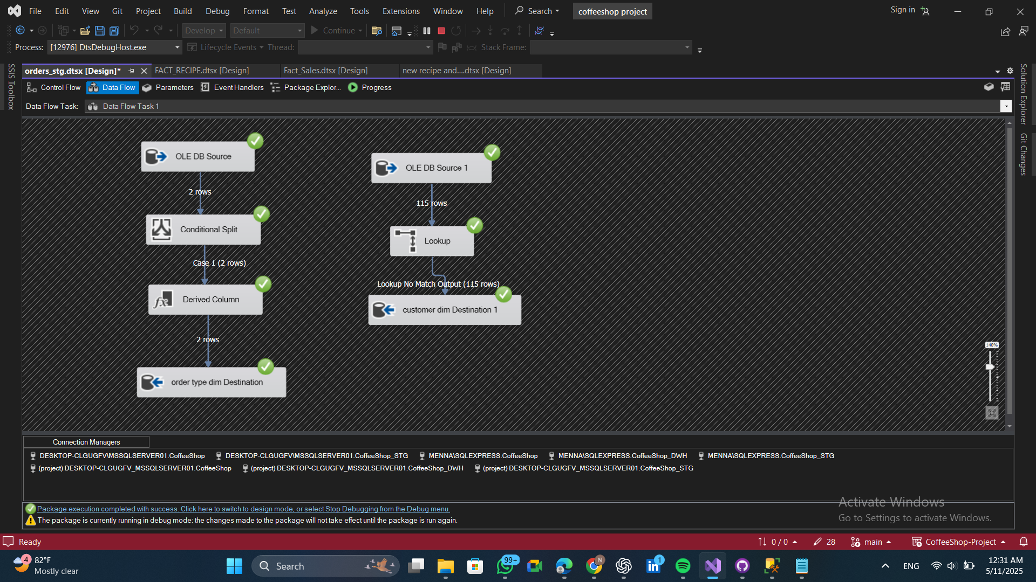**Customer Dim and Order type data flow 🡪 Retrieved from staging area of order**
* 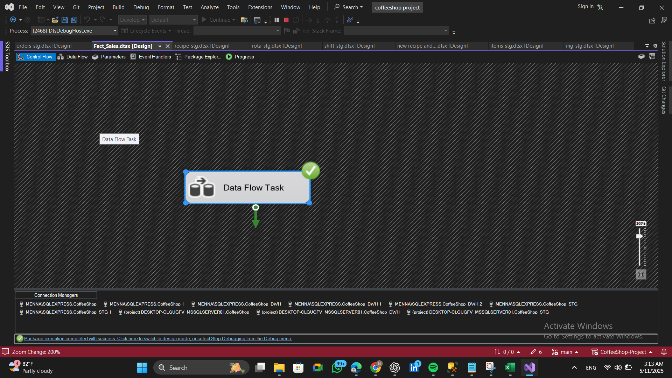**Fact Sales control flow**
* **Fact Sales data flow**
* 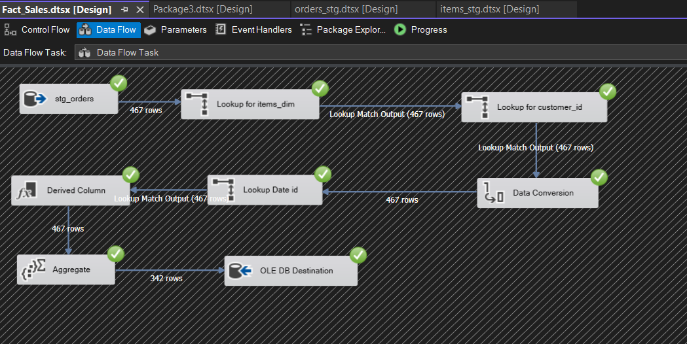Load sales data by performing lookups with item, customer, and date dimensions, then aggregate and insert the data into the fact table.
* 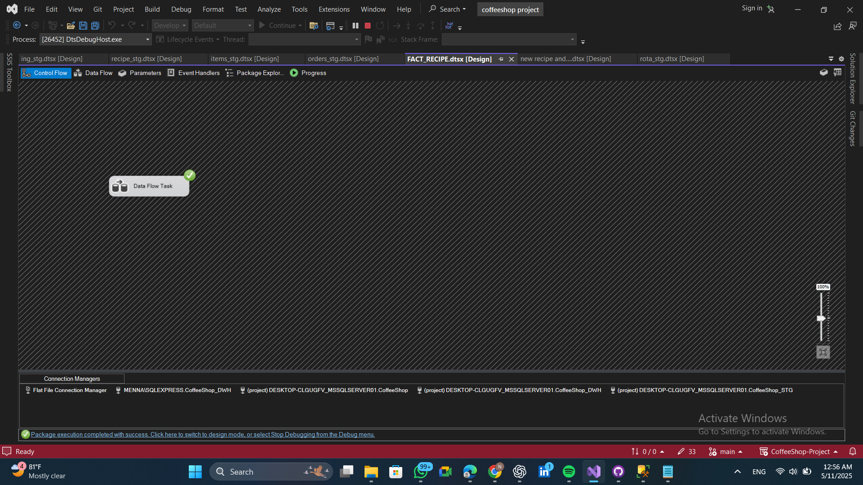**Fact Recipe control flow**
* **Fact Recipe data flow**
* 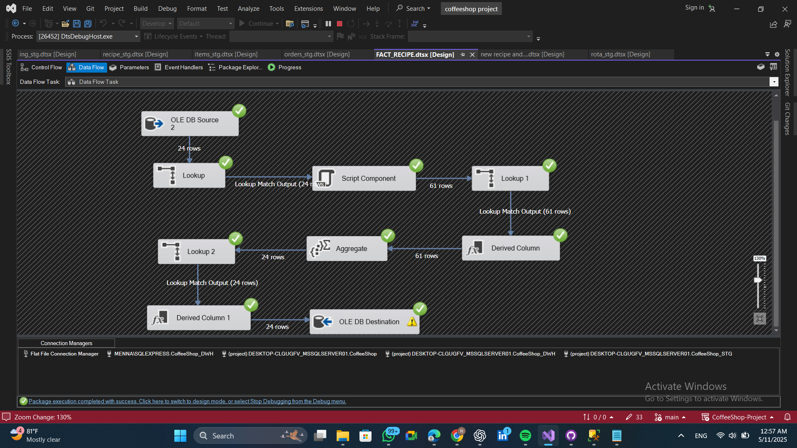Retrieve data from the recipe dimension, add a script component to fetch the ingredients, calculate the cost and profit (item price - cost), and then process the results
* 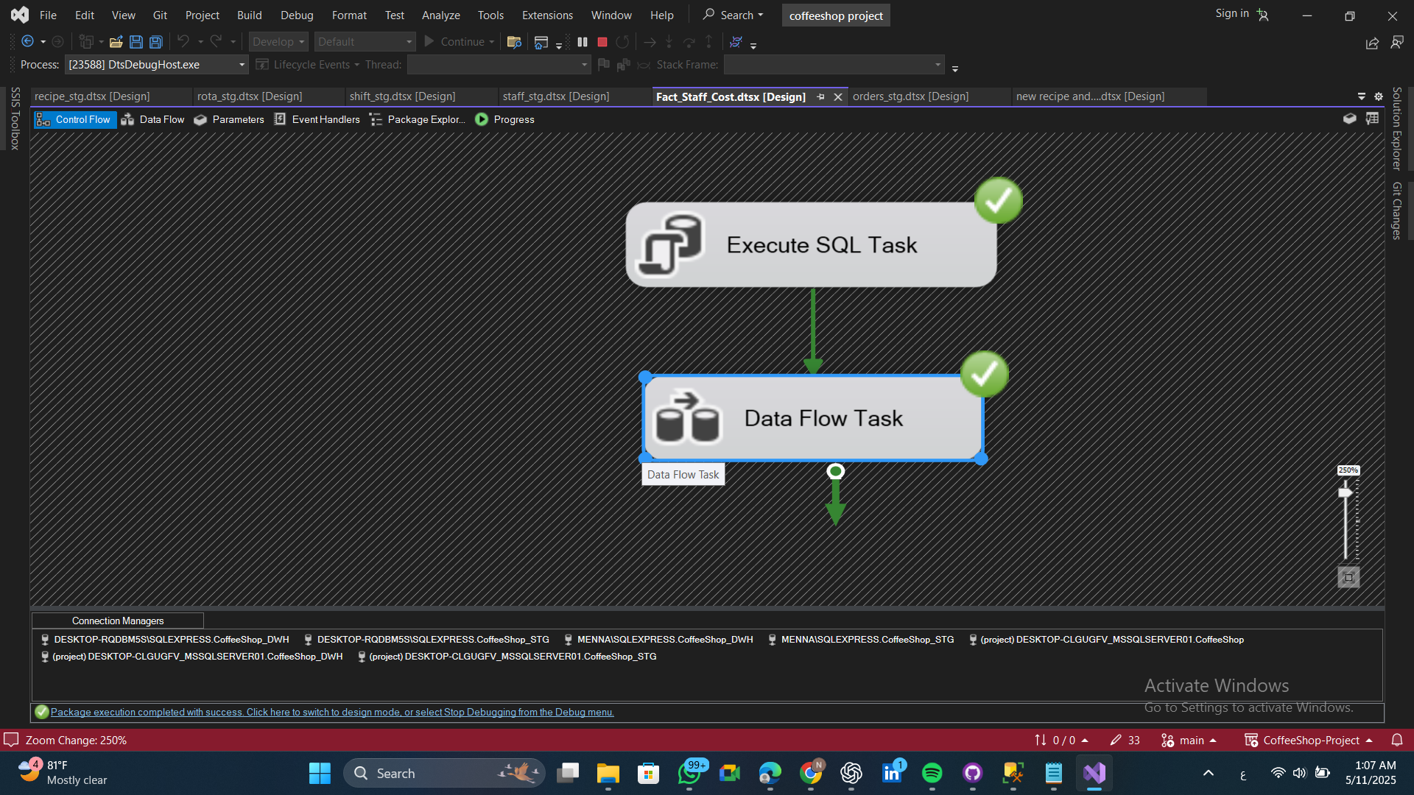**Fact Staff Cost control flow**
* **Fact Staff Cost data flow**
* 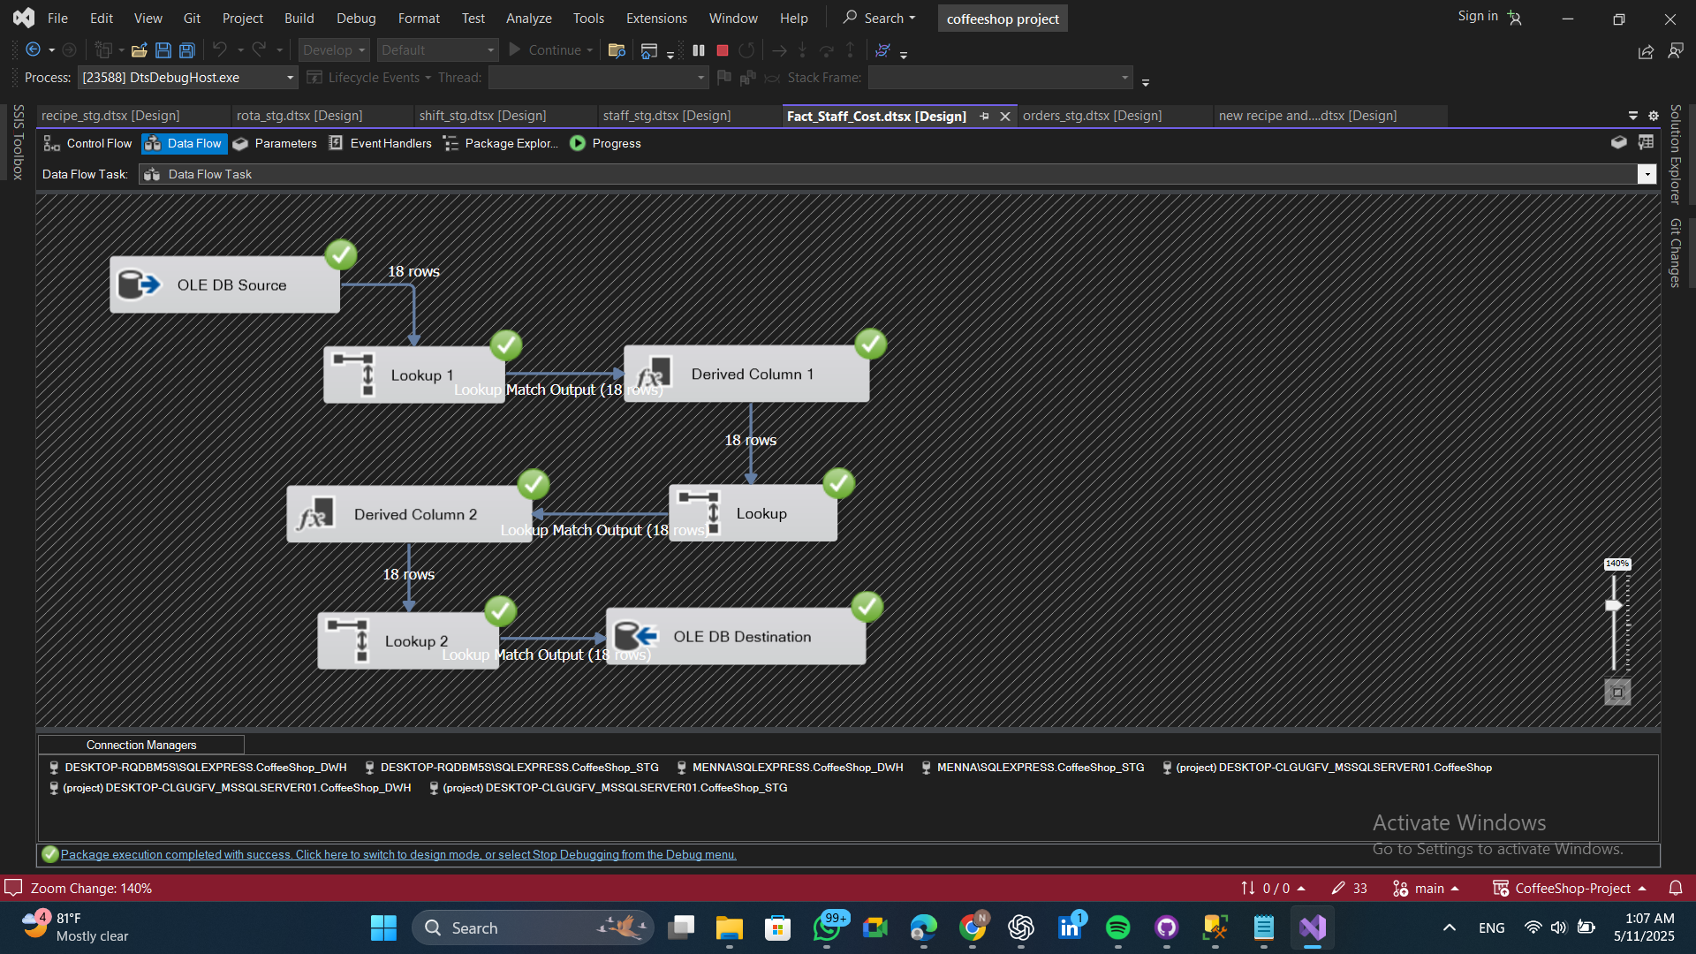Load staff cost data, add role and shift information through lookups, transform the data, and then save it to the destination
* 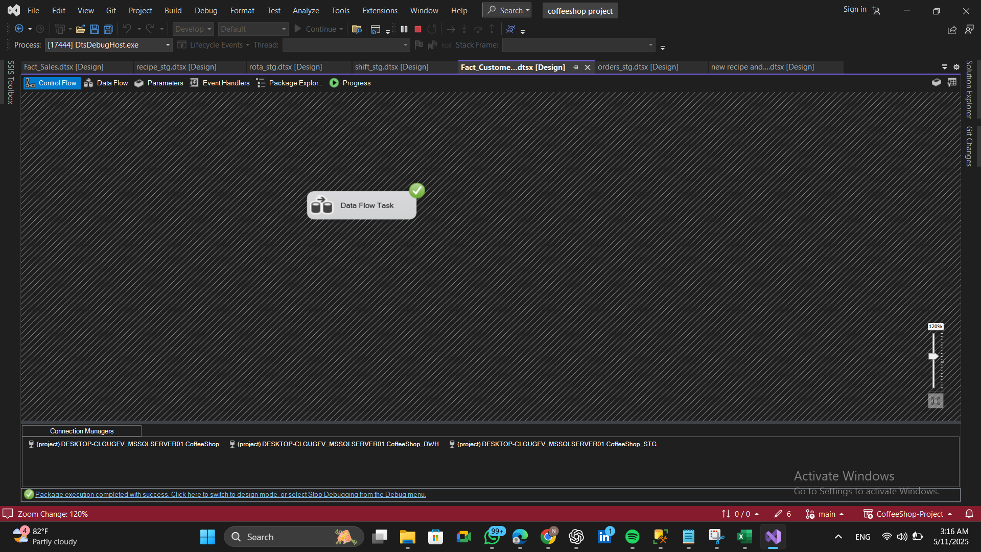**Fact Customer Visits Monthly control flow**
* **Fact Customer Visits Monthly data flow**
* 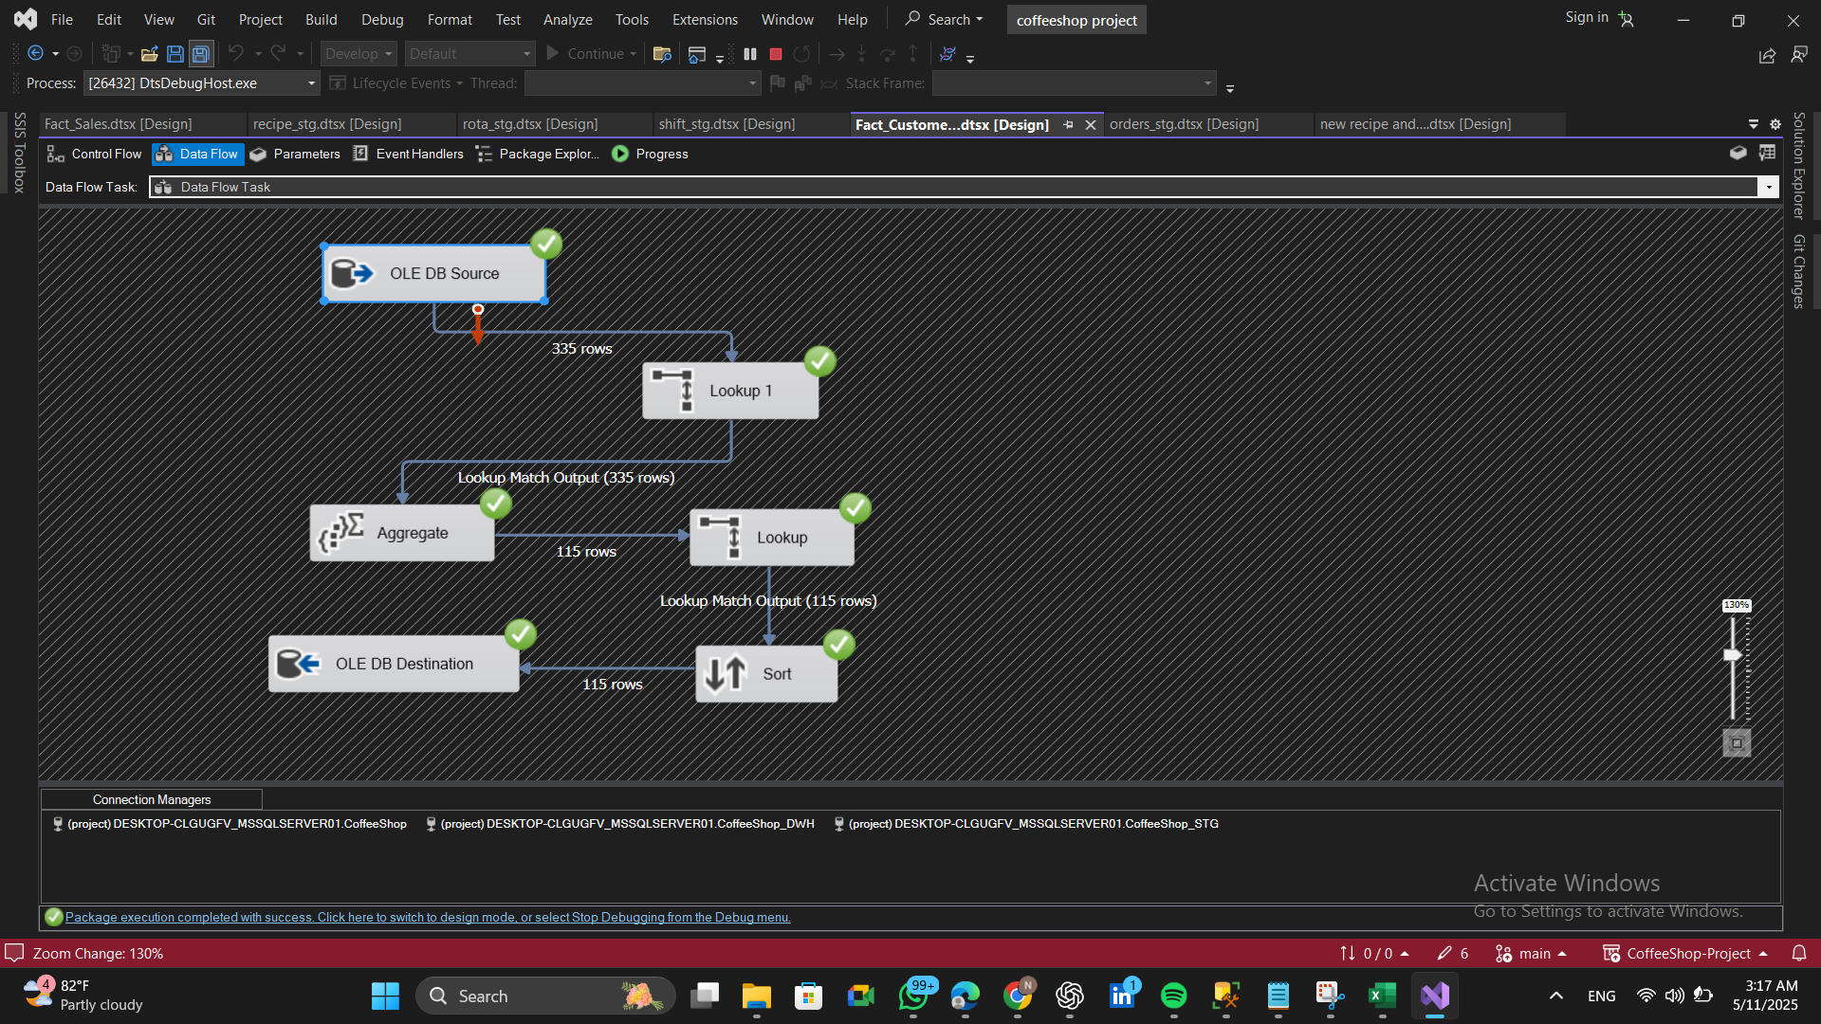Retrieve data from the fact sales, perform a lookup on the month name, aggregate by customer, month, and year, then lookup the customer name to retrieve all related data

1. 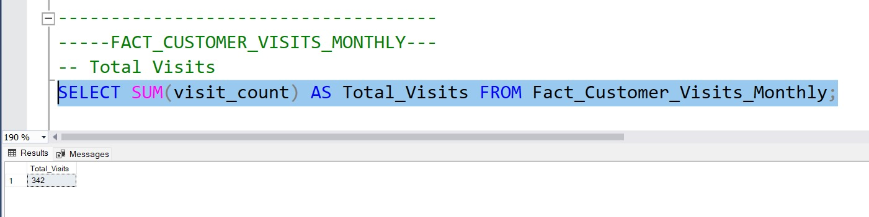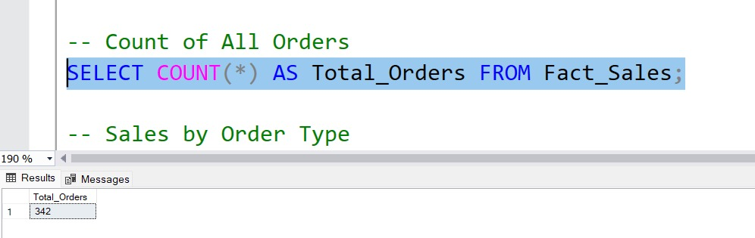Analytical Queries

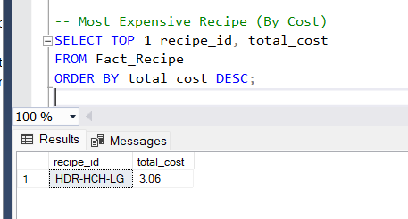

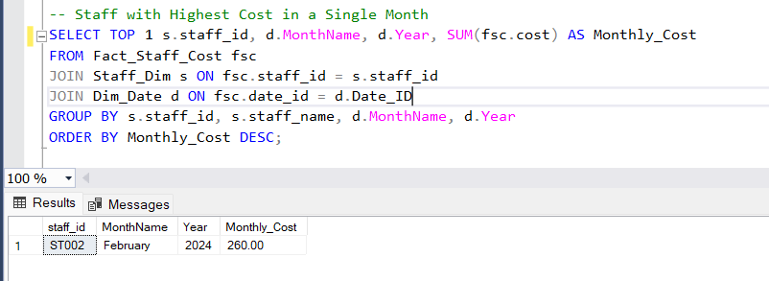

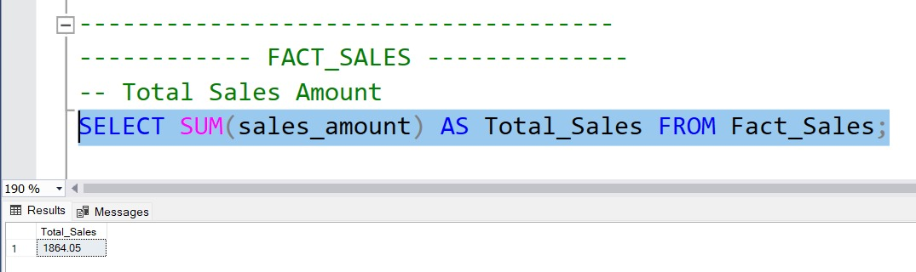

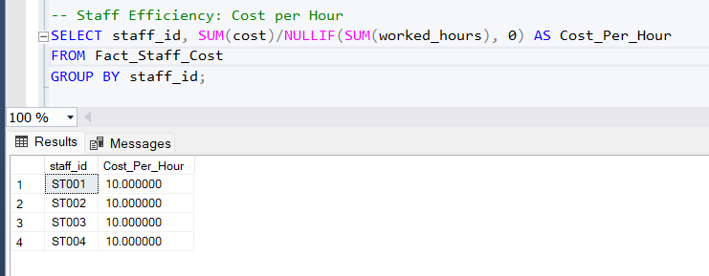

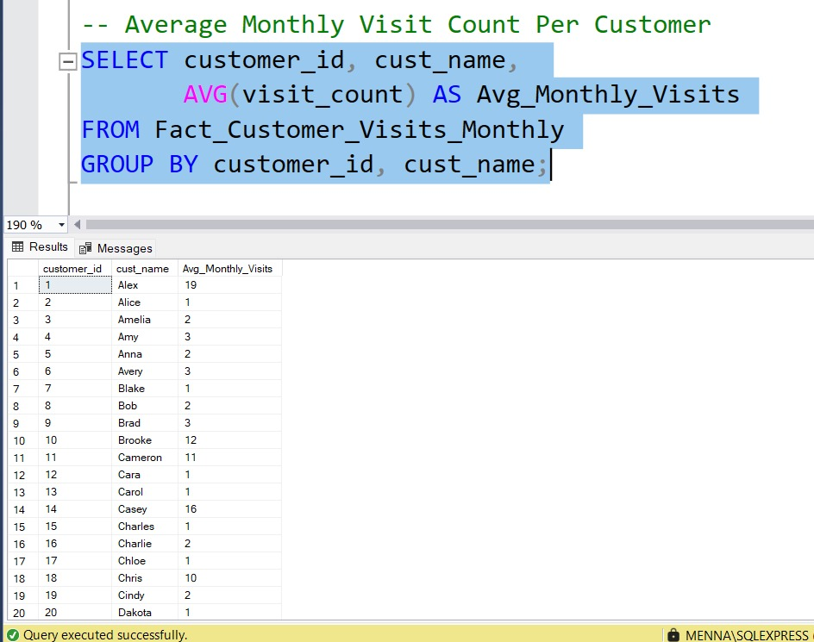

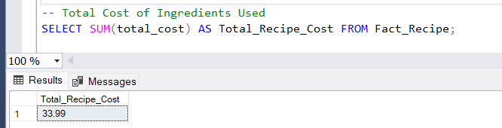

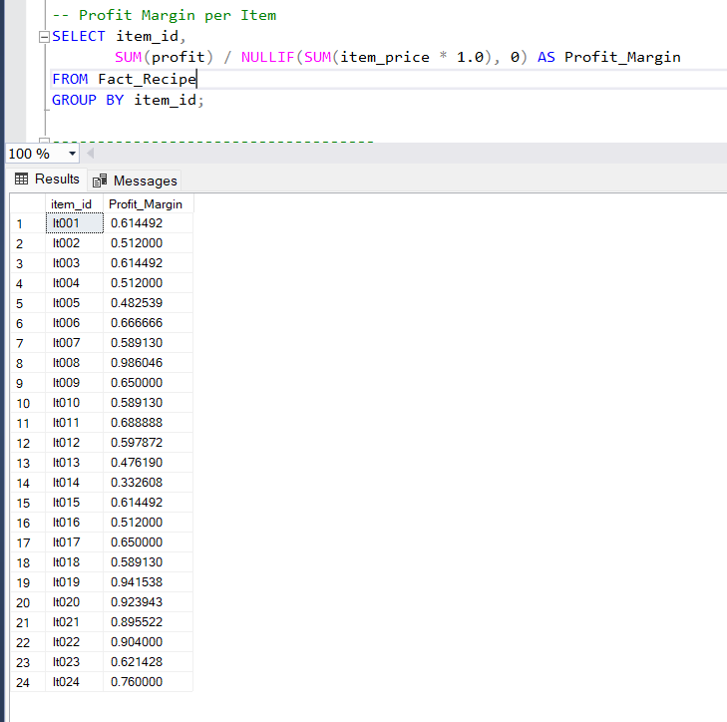

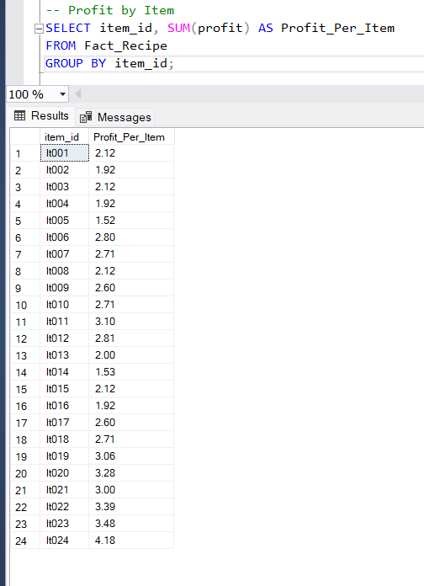

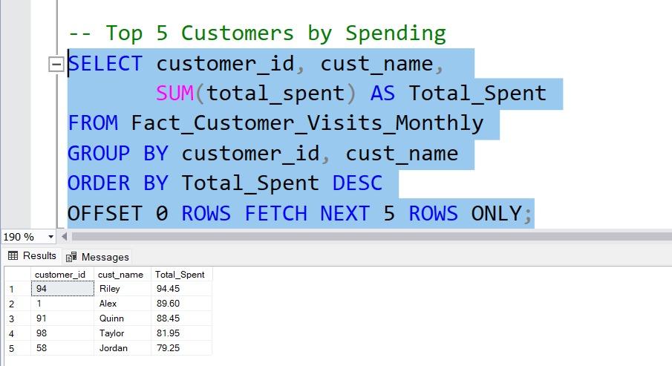

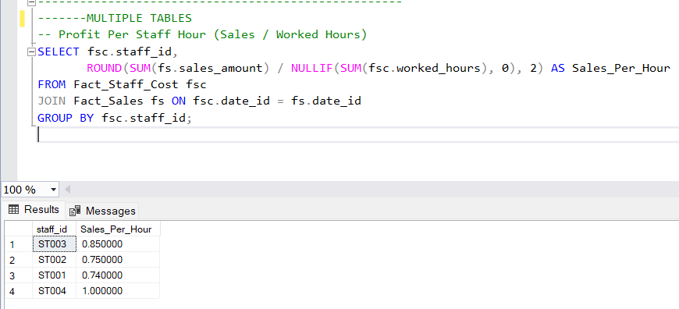

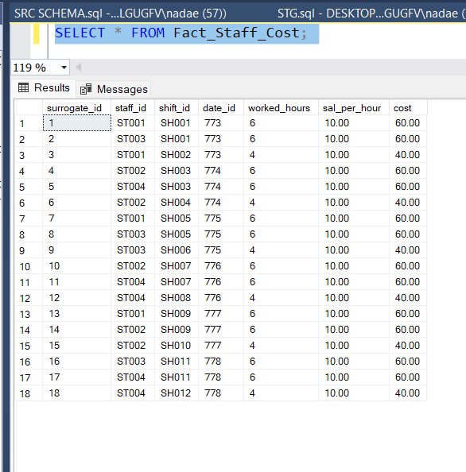

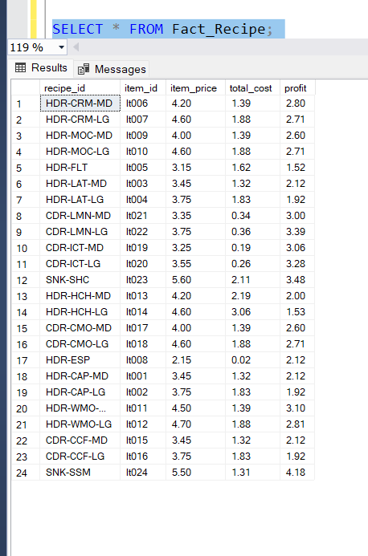

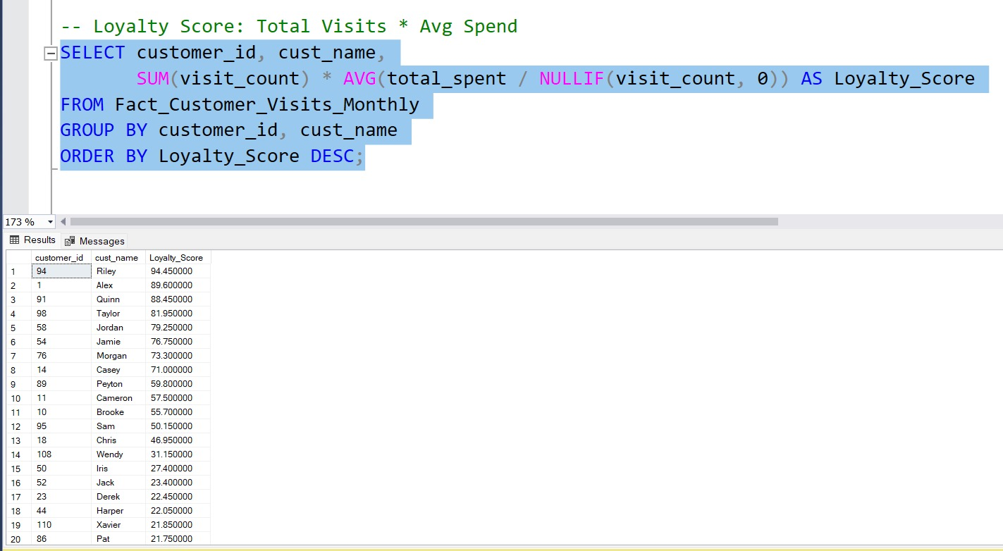

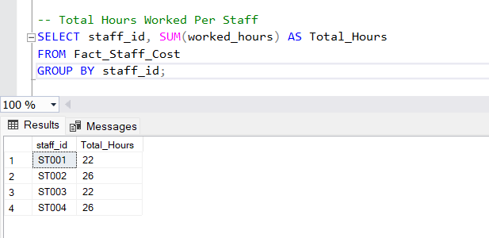

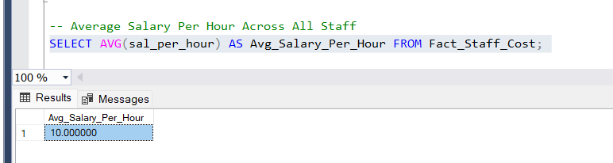

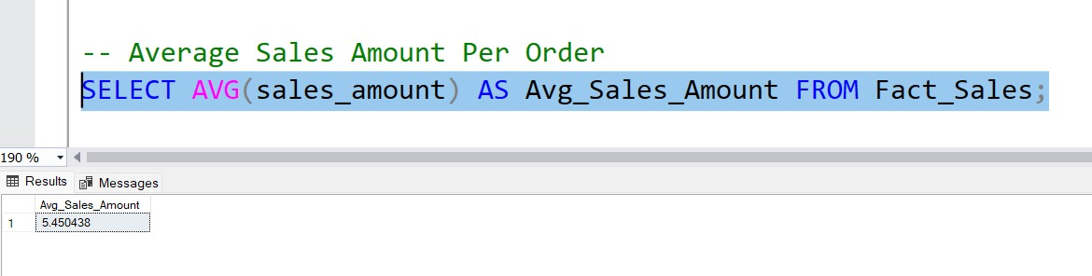

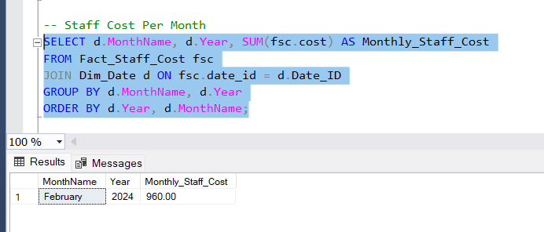

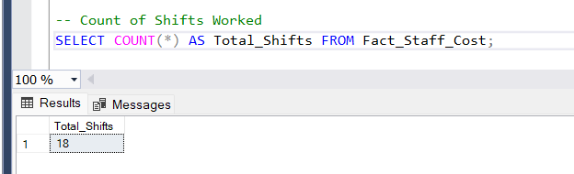

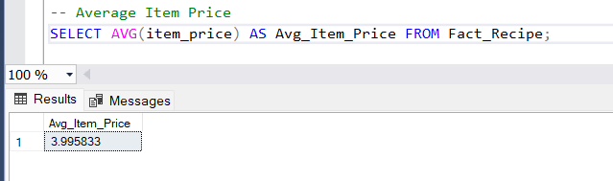

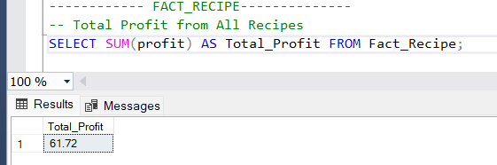

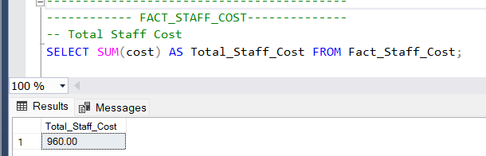

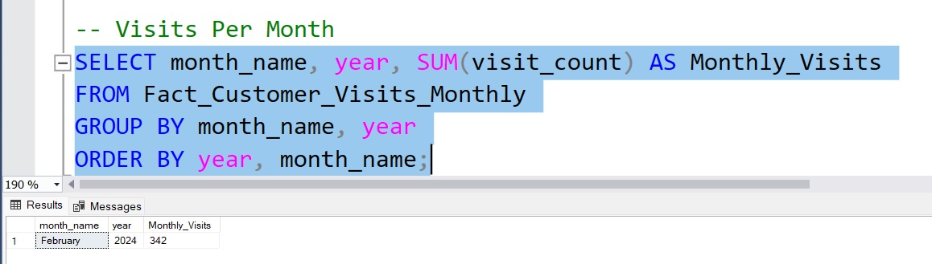

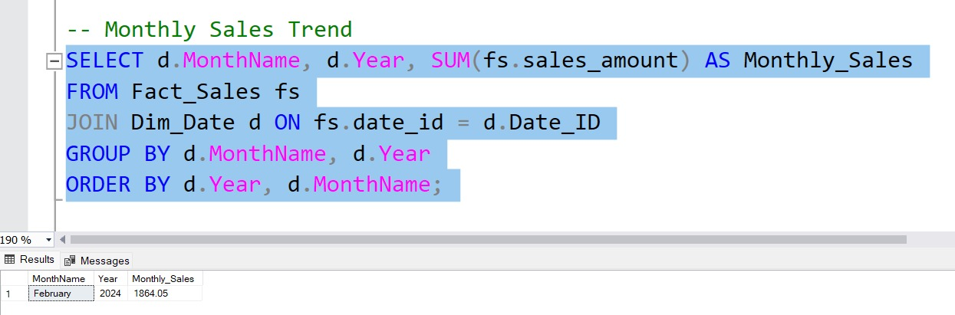

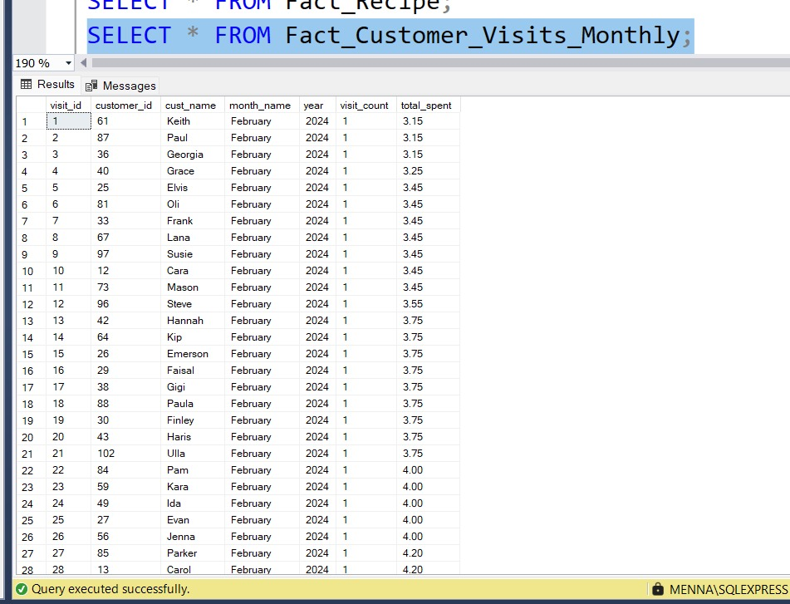

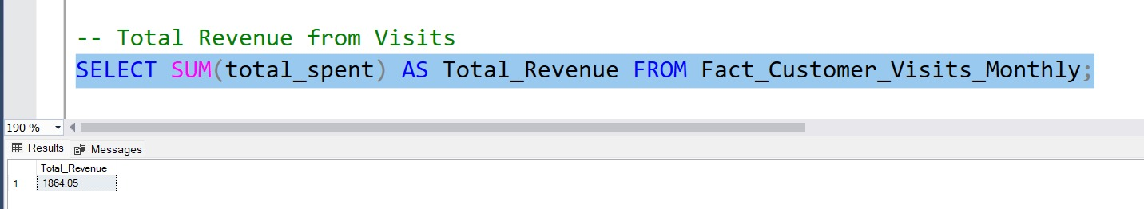

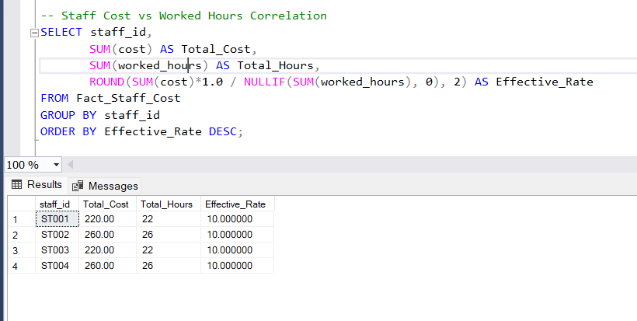

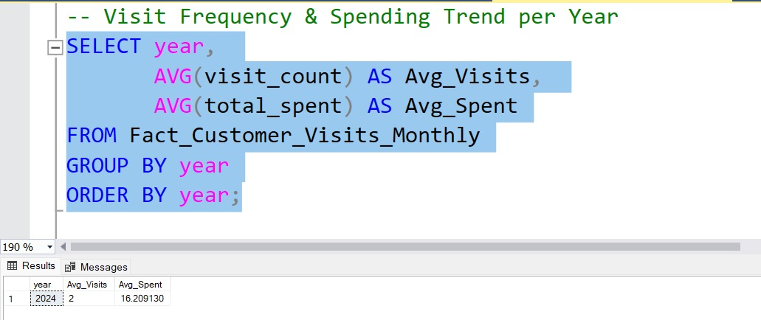

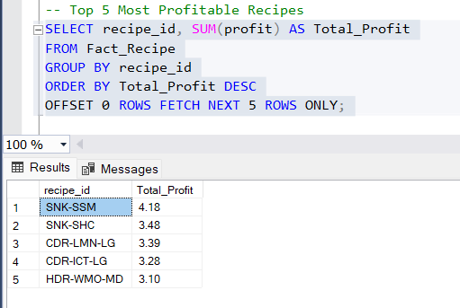

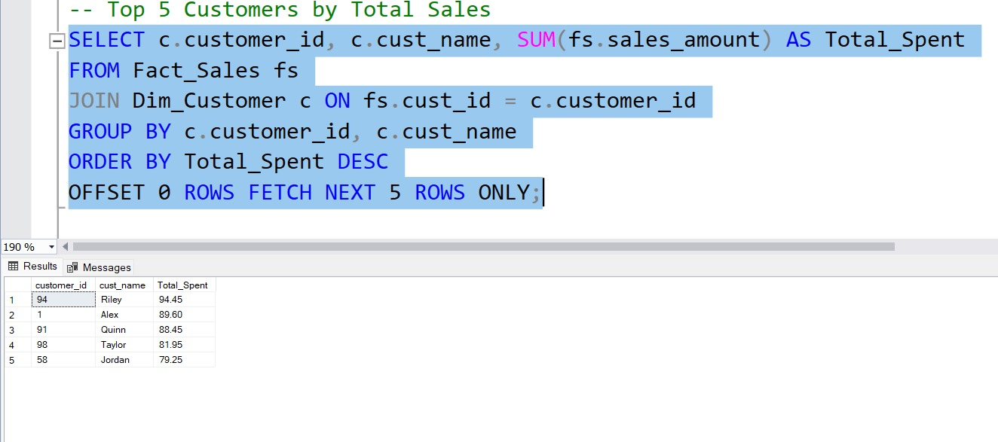

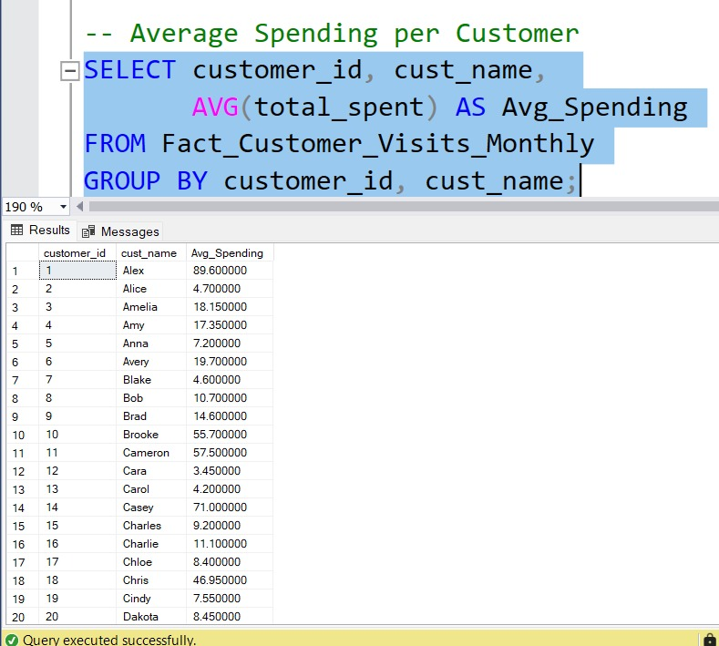

1. Screenshots of the deployed packages in SSIS with their schedule.

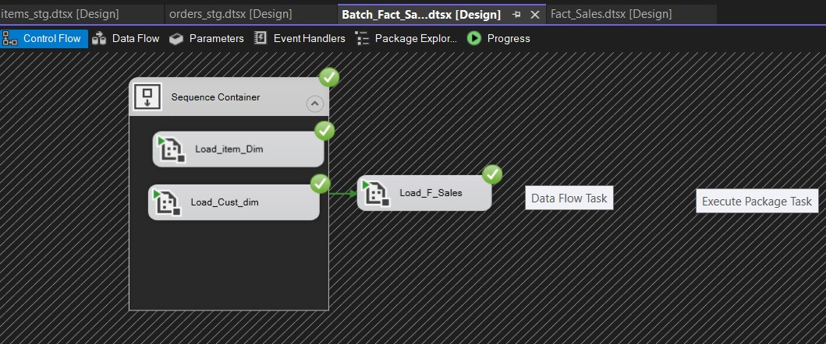

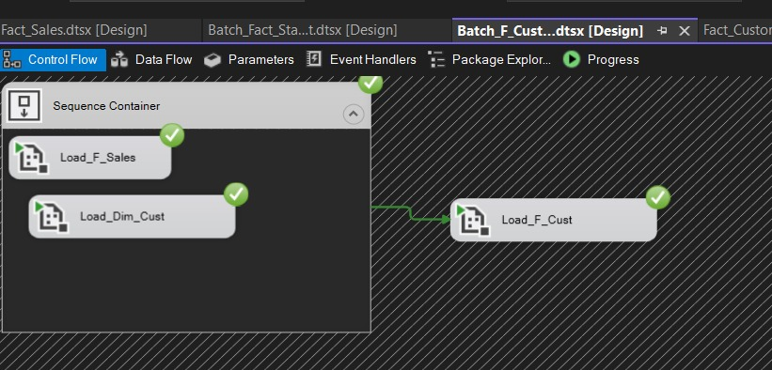

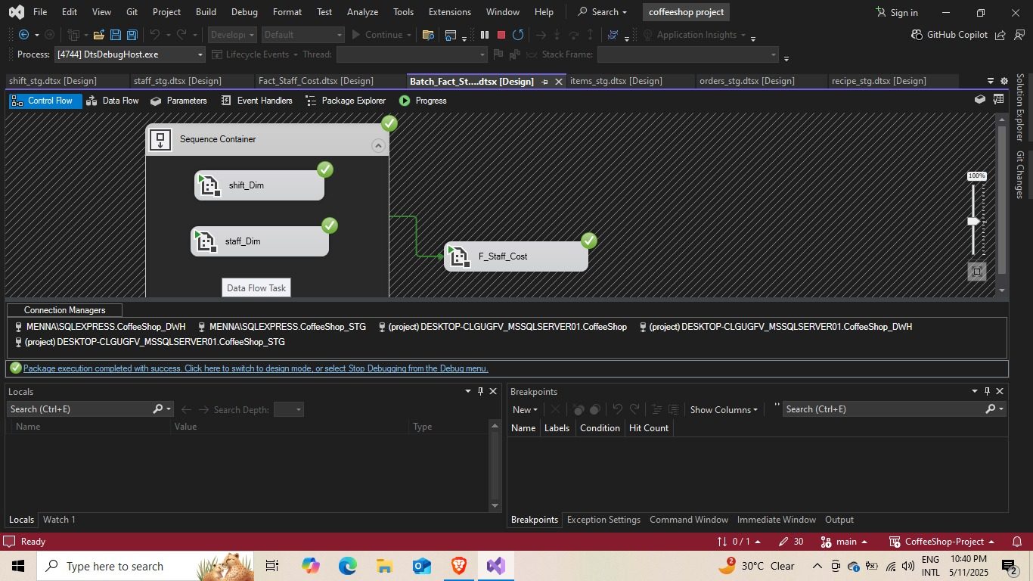

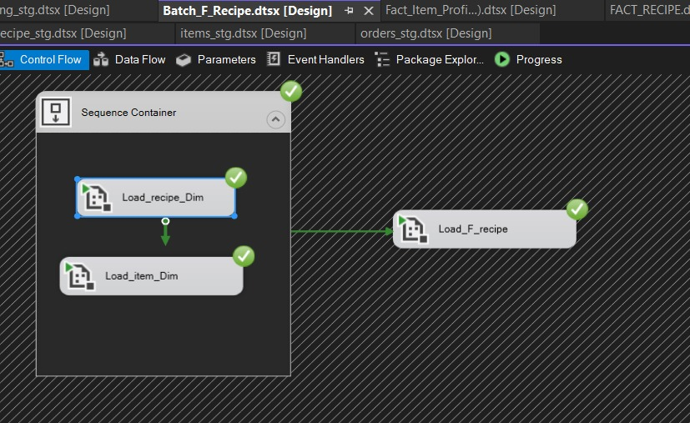

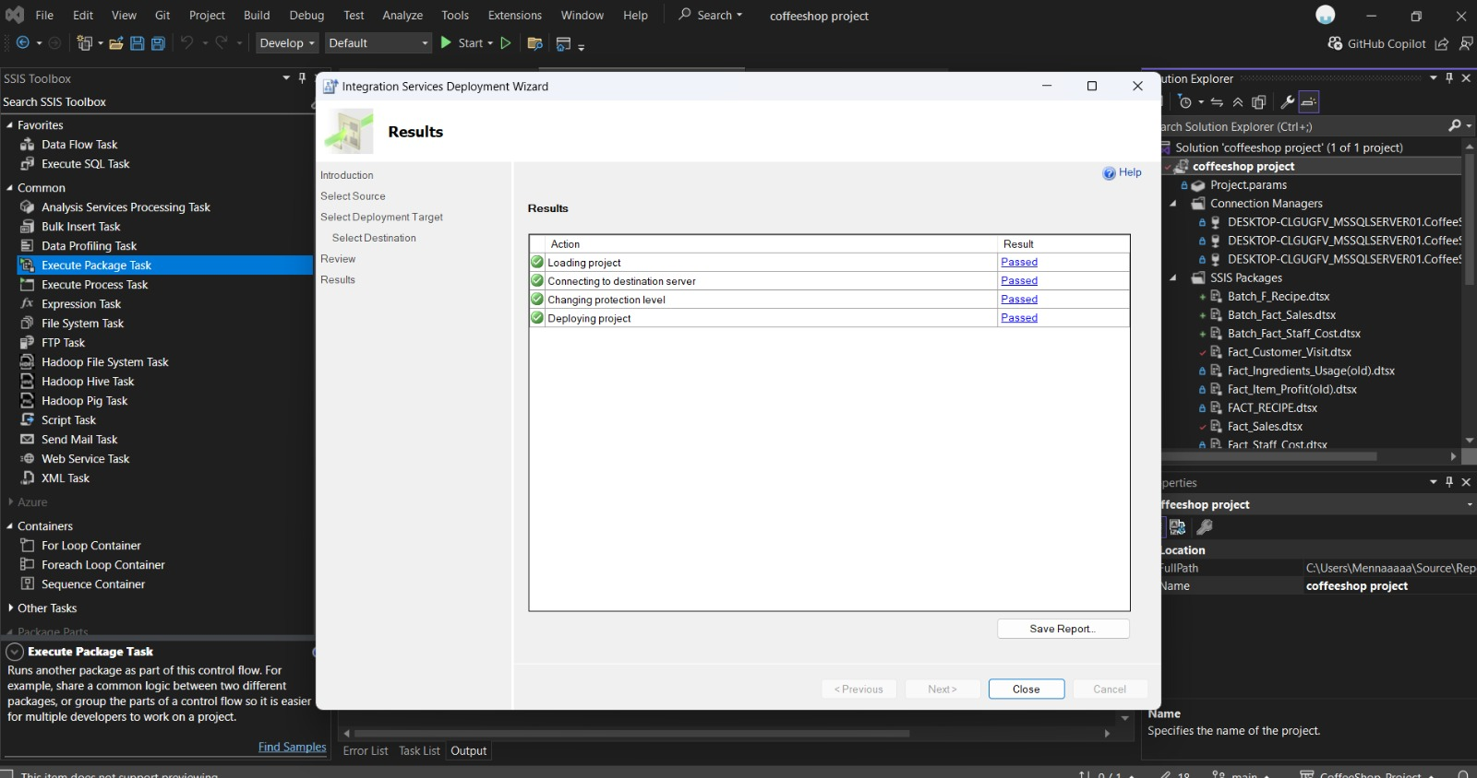

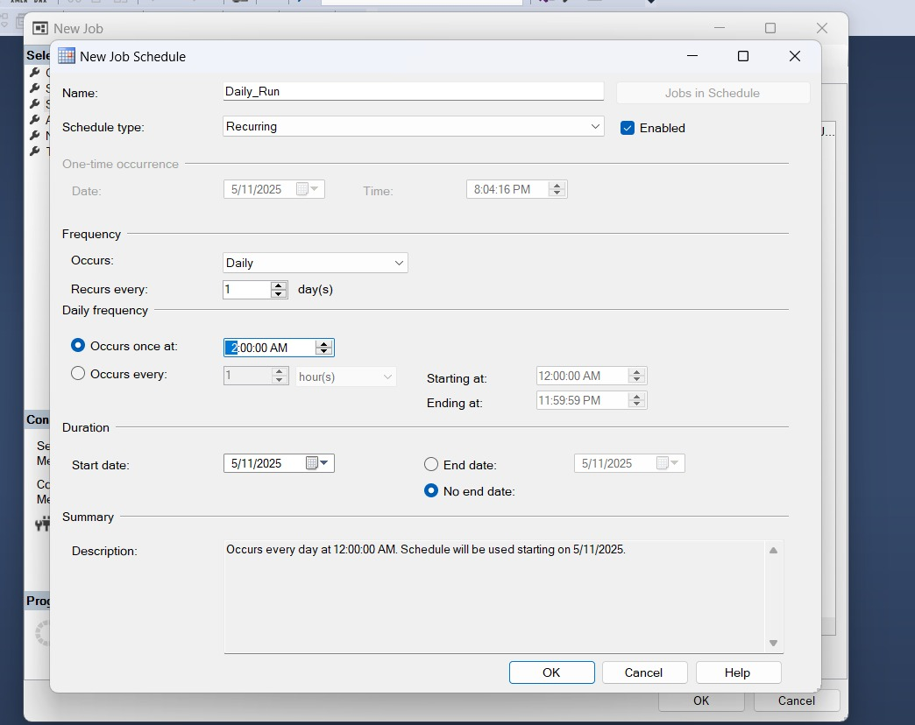

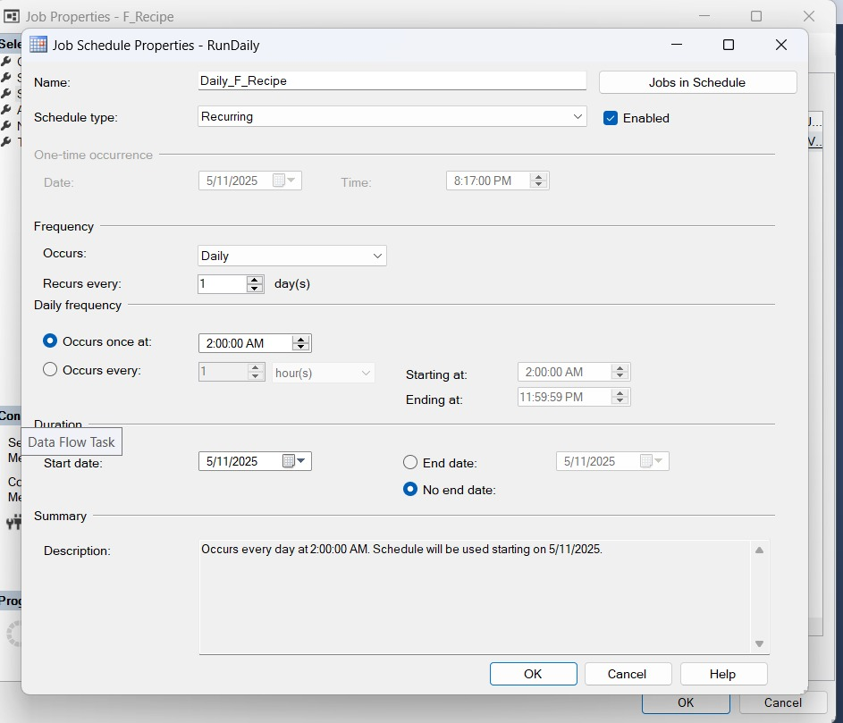

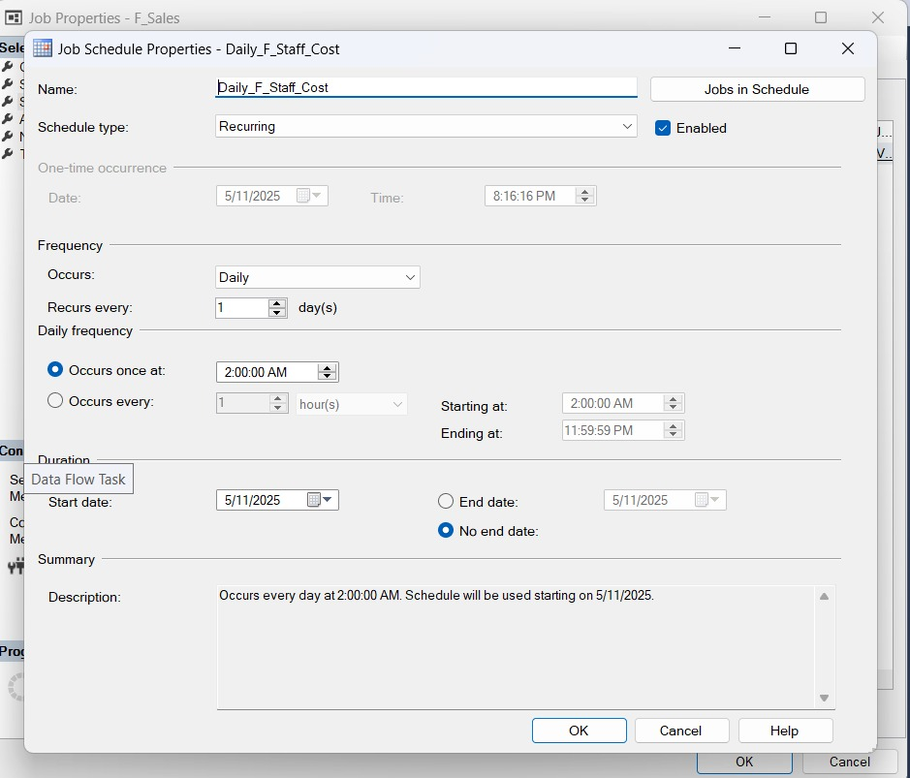

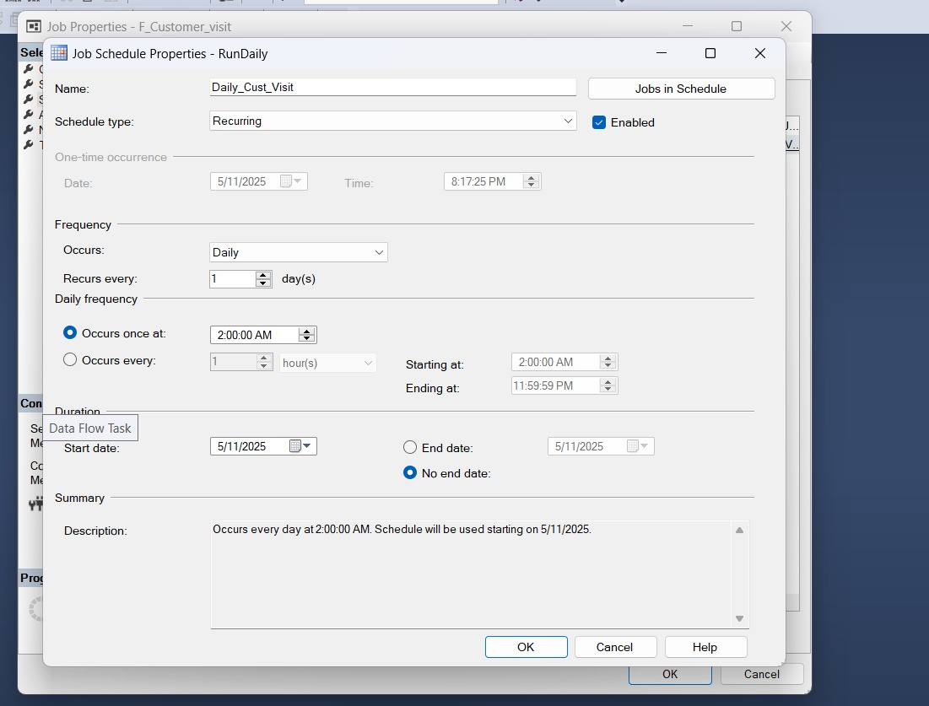

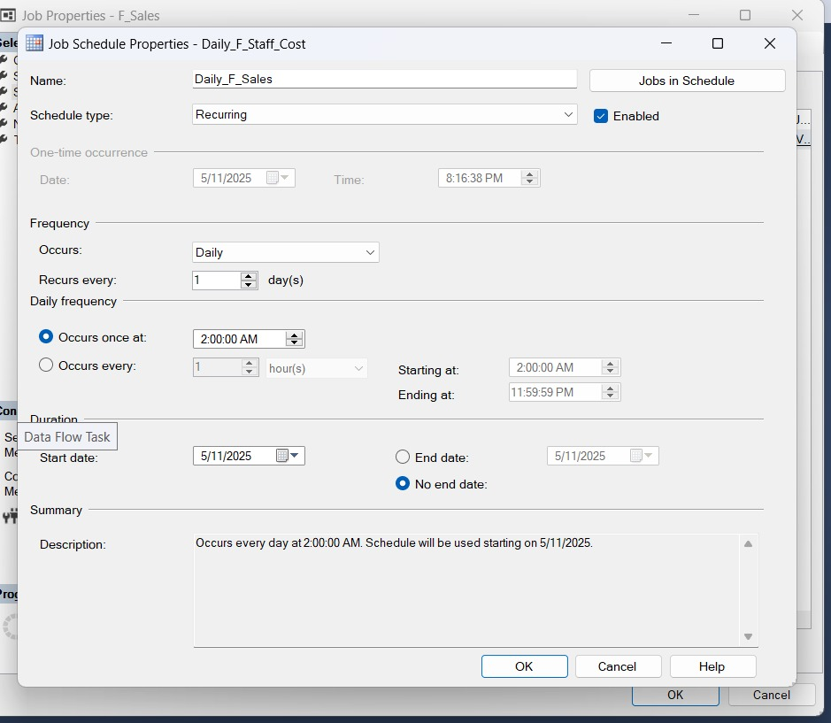

1. Data Visualization Using PowerBI.

